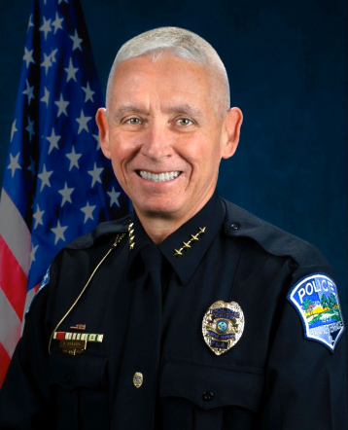
Chief Kenneth R. Albano
Chief Kenneth Albano (ret.) began his 39-year law enforcement career in 1982 as a military police officer with the 82nd Airborne Division while serving in the U.S. Army.

In February 1988, Chief Albano was hired by the Plant City Police Department. While at Plant City, he held various positions including officer, detective, patrol sergeant, and captain. As a captain, he served as the commander of Administrative Services and Criminal Investigations and as the department’s first accreditation manager.

In April 2006, Chief Albano joined the Temple Terrace Police Department as the commander of the Patrol Division. Chief Albano also served as the commander of the Criminal Investigations Division, the Special Weapons and Tactics Team (S.W.A.T.), and the Crisis Response Team and Training Unit.

Chief Albano was appointed chief of police on December 23, 2008, and served in that role until his retirement on February 28, 2025. He is known as a dedicated Christian man, a loving husband, father, and Papa; and for fostering trust and transparency within the community, as a visionary leader whose efforts led to the establishment of Temple Terrace’s first Boys and Girls Club, and for his unwavering commitment to public safety.

He is a past president and life member of both the Florida Police Chiefs Association and the Tampa Bay Area Chiefs of Police Association.

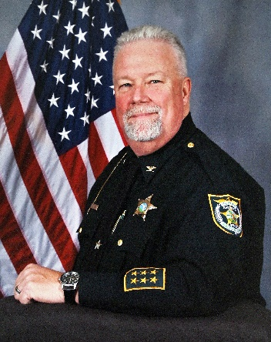
Undersheriff Jerry Bryan
Undersheriff Jerry Bryan (ret.) began his 36-year career in law enforcement at the Okaloosa County Sheriff's Office in 1985. From 1986 - 1988, Undersheriff Bryan worked for the Wakulla County Sheriff's Office, serving in both patrol and investigations. He returned to the Okaloosa County Sheriff's Office in 1988, serving as a field training officer and a member of the narcotics task force. In 1994, he joined the Florida Department of Agriculture and Consumer Services, Office of Inspector General where he served as a lieutenant and chief of Investigations. He joined the Office of Agricultural Law Enforcement (OALE) in 2001, serving as captain in the Bureau of Investigative Services, chief of the Bureau of Uniform Services, lieutenant colonel, and colonel. As colonel, Undersheriff Bryan modernized the agency, focusing on efficiency and supporting the department's vast agricultural and consumer oversight responsibilities.
Undersheriff Bryan was a pioneer in servant leadership. He was ahead of his time in developing leaders and establishing culture benefiting everyone within the agency. He recognized talent and challenged people to exceed their expectations of themselves. He honored his staff through vision, empowerment, influence, and being a servant. Bryan retired from OALE in May 2016. In December 2016, Undersheriff Bryan was appointed chief deputy by Sheriff Michael Adkinson, Jr. at the Walton County Sheriff's Office. He faithfully served in Walton County until August 2021, when he retired as undersheriff. At the Walton County Sheriff’s Office, he was instrumental in elevating pay for administrative support personnel, which increased organizational morale and employee quality of life.
Undersheriff Bryan holds a bachelor's degree in criminology from Florida State University and is a certified public manager and certified inspector general. Undersheriff Bryan was born and raised in Fort Walton Beach and resides in Tallahassee.

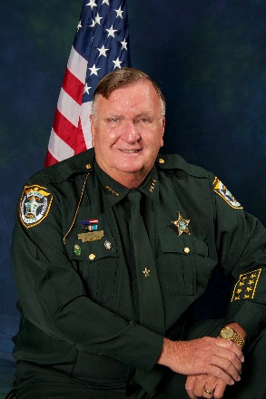
Sheriff William “Bill” Farmer Jr.
Sheriff William O. Farmer Jr. (ret.), “Bill,” a U.S. Army veteran, has devoted 56 years to law enforcement. He began his career with the FBI in Washington, D.C., in 1965. Later working with the Florida Department of Corrections and local police departments before joining the Sumter County Sheriff’s Office in 1971. Over the next 25 years, he served as a sergeant up to chief deputy before deciding to run for sheriff. Elected as sheriff in 1996, he served seven consecutive terms, the longest in county history.
Sheriff Farmer, who graduated cum laude, earned a bachelor’s degree in criminology from St. Leo University. He is a graduate of the FBI National Academy (195th Session), the 1997 Florida Criminal Justice Executive Institute’s Chief Executive Seminar, and the National Sheriffs’ Institute Executive Development Program.
During his tenure, he rose through the Florida Sheriffs Association (FSA) board to become president, the only Florida sheriff to serve two consecutive terms. As president, he led the appointment of a new executive director and formed the committee that developed a new FSA headquarters after the original headquarters was destroyed by fire. He also served as chaplain for the FSA, a board member for the Florida Sheriffs Risk Management Fund Board, and chairman of the Florida Model Jail Standards Committee. Sheriff Farmer chaired the Florida Sheriffs Youth Ranches Board of Directors for two terms, raised over $100,000 for youth programs, and launched a children’s bicycle initiative. In recognition of his lasting impact, the Public Safety Center in The Villages was named in his honor.
He retired in January 2025. Sheriff Farmer’s legacy reflects visionary leadership, integrity, and a lifetime of public service.

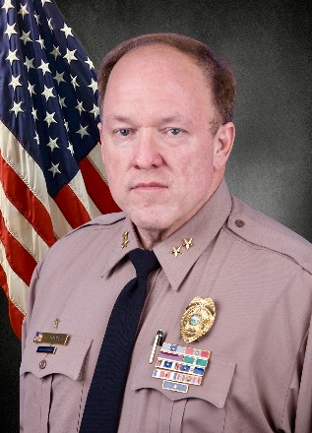
Chief Charles E. Nanney
Chief Charles E. Nanney (ret.) began his career at the Miami-Dade Police Department (MDPD) in 1987 and served 31 years as an officer up to division chief. He was on the front lines during the county’s peak of crime. He later served almost four years as the assistant chief at the South Miami Police Department, serving South Florida residents for nearly 35 years.

He led the South District, the Carol City District, the Northside District, the Narcotics, Organized Crime and Gang Bureau, the Robbery Bureau, the Warrants Bureau, and the Special Investigations Division. He always intertwined community policing in all his enforcement efforts.
Chief Nanney has advocated for police-community relations and has served on numerous boards such as the South Florida HIDTA Board, the Urban League of Greater Miami, and the Embrace Girls Foundation.

Chief Nanney has amassed innumerable commendations and earned the following departmental awards: two Distinguished Officer of the Month awards, two Silver Medals of Valor, two Bronze Medals of Valor, two Lifesaving Awards, a Purple Heart, two Exceptional Service Awards, and three Employee Excellence Awards. At his retirement, he was one of the most decorated police officers at MDPD. In 2018, Miami-Dade County honored him with a proclamation naming October 18th as Chief Charles E. Nanney Day.

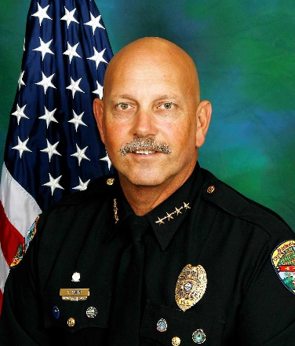
Chief Stephen J. Stepp
Chief Stephen Stepp (ret.) began his service in the U.S. Army and Florida National Guard. He began his law enforcement career with the North Miami Police Department, serving from 1978 - 2003. During his tenure, he worked as a patrol officer, instructor, K-9 handler, school resource officer, and investigator. As supervisor of the Vice, Intelligence and Narcotics Unit, he led task forces focused on the arrest of violent felons, conducted undercover narcotics operations, and dismantled criminal organizations. Rising to assistant chief, Chief Stepp remained active in the community, serving on the Senior Citizens Foundation Board and coaching youth sports for over 25 years.

From 2003 - 2018, Chief Stepp served as chief of police for the City of Palm Beach Gardens. He enhanced community policing through problem-solving partnerships and created a citizen’s mobile patrol, an award-winning Police Explorer program, and citizen’s police academy. He founded Palm Beach Gardens Police Foundation to fund scholarships, events, and specialized equipment and training. He played a key role in creating an indoor tactical training facility and 9-1-1 dispatch and emergency operations center. Chief Stepp served Palm Beach County as a member of the Criminal Justice Commission and as president of the Association of Chiefs of Police. His career is marked by numerous awards for leadership, courage, and community service.

