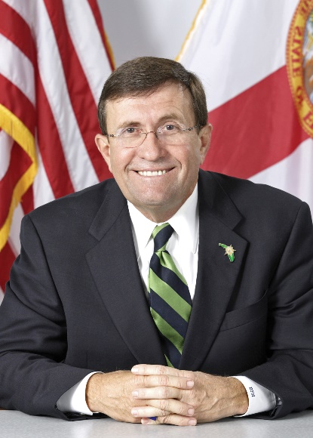
David F. Harvey started his law enforcement career in 1972 as a parole and probation officer for Franklin and Wakulla counties. In 1976, he was elected sheriff of Wakulla County at 26 years old. He went on to serve nine terms and retired 35 years later as Florida’s longest tenured sheriff. He grew an office of 11 employees and an 18-bed jail to one with 180 employees and a 350-bed jail. The Wakulla County Sheriff’s Office (WCSO) also became one of the state’s first rural sheriff’s offices to be accredited in both law enforcement and corrections. Under his leadership, the WCSO also interdicted and eradicated over $90 million in cartel drug importation between the 1970s and 1990s. In 1978, he became a founding board member and visionary of the Florida Sheriffs Risk Management Fund (FSRMF). In 2010, while still sheriff and chairman of the FSRMF Board, he proposed the sheriffs to not only own their self-insurance funds, but to also manage them in-house rather than outsourcing to a third party. After a cost-benefit analysis proved feasible, he retired as sheriff and was unanimously selected to be the first-ever executive director of the FSRMF. FRSMF became the largest owned-and-operated law enforcement self-insurance fund in the nation, providing insurance to 59 sheriffs and 20,000 sworn and non-sworn personnel with over $400 million of investible assets.

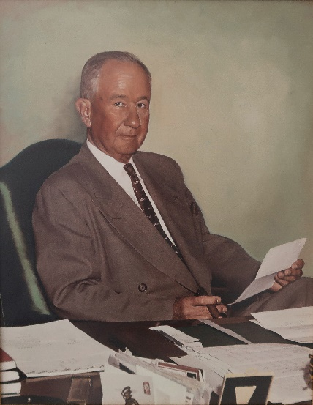
Henry Neil Kirkman began his career in law enforcement in July of 1936 as major of the State Road Department’s Traffic Enforcement Division. Three years later, Department of Public Safety and Florida Highway Patrol Director W.F. Reid appointed Kirkman as captain of the newly created Florida Highway Patrol. The appointment was due, in large part, to his experience in the United States Army during World War I. Just a few years later, Kirkman was called to serve his country once again as a soldier in the United States Army during World War II, where he was awarded the Legion of Merit medal and achieved the rank of colonel before he retired from the Armed Forces in 1945. Upon his arrival home from war, Governor Millard Caldwell and his Cabinet unanimously appointed Colonel Kirkman as director of the state’s Department of Public Safety. He held this position until 1969 when he became executive director of the newly formed Department of Highway Safety and Motor Vehicles. Colonel Kirkman retired on February 11, 1970. Under his direction, improvements were made in the areas of growth, personnel, administration and training. He laid the groundwork for what has become the motto of the Florida Highway Patrol: “Courtesy, Service and Protection.” Because of Colonel Kirkman’s outstanding service to the citizens of Florida, the General Headquarters building of the Department of Highway Safety and Motor Vehicles is designated as the Neil Kirkman Building.

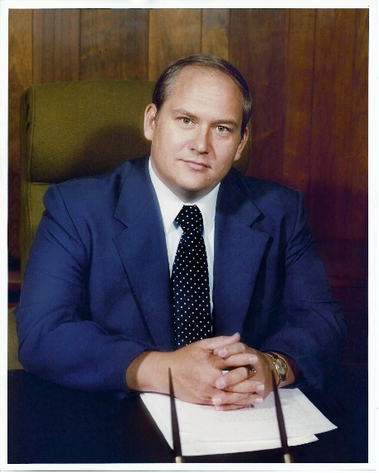
Arthur (“Lee”) McGehee began working part time for the Marion County Sheriff’s Office in 1957, at the age of 14. He received his undergraduate education at Florida State University and went on to become a patrol officer for the Ocala Police Department. In 1970, he graduated with a master’s degree in public administration from the University of Georgia. Then, in 1971, he moved to St. Petersburg to take a position as Director of Administration for Police and Fire at the Public Safety Agency. He was appointed Chief of Police for the city of Ocala in 1974, where he remained for just over 20 years. Upon retirement from the Ocala Police Department, he was appointed as director of the Florida Criminal Justice Executive Institute (FCJEI), a position he held until his untimely death on September 19, 2000. Chief McGehee also served as chairman and a founding member of the FCJEI Policy Board as well as president and lifetime member of the Florida Police Chiefs Association. Chief McGehee’s greatest goal was the professionalization of law enforcement. He was a charter member of the Commission for Florida Law Enforcement Accreditation and played a major role in helping to develop standards and requirements that agencies would have to meet in order to become accredited. Chief McGehee was seen as a pioneer in the community policing philosophy. He was highly involved in law enforcement organizations as well as his community and church. Chief McGehee was a leader, visionary and educator that impacted and influenced many current law enforcement professionals.

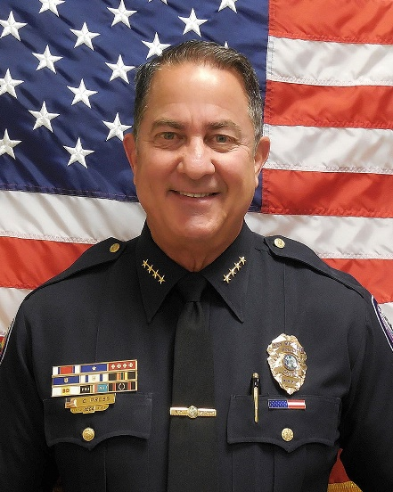
Charles R. Press began his 46-year career in law enforcement as a police officer in 1975 with the Miami Beach Police Department. Retiring as assistant chief after 29 years, he became chief of police with the Village of Key Biscayne in 2004. Chief Press developed and implemented innovative police management and community involvement programs that received local and statewide recognition. He initiated the accreditation process with the Commission for Florida Law Enforcement Accreditation (CFA), culminating in an Excelsior status. He re-created the department with a focus on transparency, accountability and excellent service delivery. He served as president of the Miami-Dade County Association of Chiefs of Police, implementing a plethora of projects designed to showcase police and community relations. He also served on the Board of Directors of the International Association of Chiefs of Police. Chief Press sought new ways to serve the local community beyond these law enforcement efforts as well, which led to his development of two new powerful initiatives: The Chief Press Foundation and the Sister City Initiative with Liberty City. Through these impactful initiatives, thousands of underprivileged and young persons have been served through Thanksgiving turkeys, Christmas toys and educational after-school programs. These efforts were driven by Chief Press’ commitment to improve police/inner-city relationships. With his heart for the community and advancements in law enforcement, Chief Press is recognized as a resolute motivational leader and law enforcement professional with an uncompromising commitment to integrity, duty and honor.
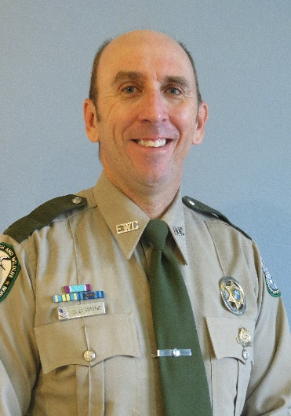
Stephen (“Steve”) D. Wayne began his law enforcement career in 1991, when he was accepted into the Florida Game and Freshwater Fish Commission's Law Enforcement Academy. Upon graduation, he served as an officer in Okeechobee County and later in Lake County, eventually promoting to lieutenant in 2003. With his promotion to captain in 2007, he led 30 officers across Brevard, Indian River and Osceola counties until 2012, when he decided to direct his career towards investigations and became the first full-time port investigator for the Florida Fish and Wildlife Conservation Commission (FWC). His hard work throughout the next nine years brought to life one of the most robust and effective fish and wildlife port investigation units in the nation, focusing on the illegal sale, import, export and commercialization of fish and wildlife resources. Their focused efforts not only benefit the state of Florida but also help to impact fish and wildlife conservation on a national and international level. Recognizing the importance of partnerships, Investigator Wayne also excelled at developing valuable relationships with other federal, state and local organizations to aid in FWC’s mission. Investigator Wayne’s retirement in 2021 brought a close to 30 years of dedicated service, which established a lasting legacy at the FWC as the Port Investigation Unit's continued hard work ensures that Florida's fish, wildlife and other priceless natural resources are conserved for future generations.

