School Guardian Management System (SGMS)

Frequently Asked Questions

UPDATED October 1, 2025

**What is a** **School Guardian or School Security Guard?**

* **Response:** School Guardians and School Security Guards are defined under s. 1006.12 and s. 30.15 Florida Statutes. As of 7/1/2025, both are required to be entered and maintained in SGMS.

**How do I get SGMS access**?

* 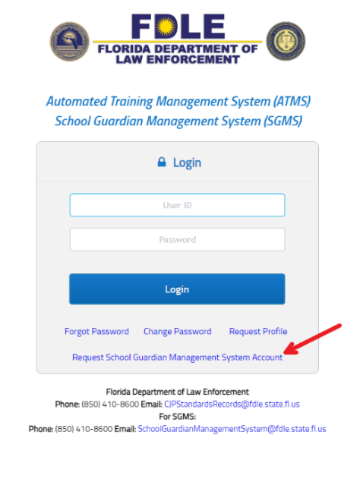**Response**: To gain access to SGMS, please go to the ATMS/SGMS login screen [here](https://atms.fdle.state.fl.us/atms/shiroLogin.jsf), click on the “Request School Guardian Management System Account,” and follow the on-screen instructions; see the picture below.

**Our sheriff office has no training scheduled for a quarter, is it still mandatory to submit a quarterly training report indicating no training is planned?**

* **Response:** Sheriff offices shall report on a quarterly basis any upcoming school guardian or school security guard training to FDLE. The training report form and email address for reporting may be found at [https://www.fdle.state.fl.us/CJSTC/School-Guardian-Training-Course-Calendar. As of 7/1/2025](https://www.fdle.state.fl.us/CJSTC/School-Guardian-Training-Course-Calendar.%20As%20of%207/1/2025). If no trainings are scheduled, the sheriff is not required to report.

The following website is available to track school guardian training and provide reporting instructions for your convenience. <https://www.fdle.state.fl.us/CJSTC/School-Guardian-Training-Course-Calendar>

*Also, please note that sheriffs are required to notify FDLE within 30 days of certifying a guardian/security guard. Guardian/security guard certification will be reported to FDLE through SGMS.

**I am a law enforcement user and logged into ATMS but do not see anything about the School Guardians/Security Guards**.

* **Response**: If you are a sheriff’s office and do not see SGMS after requesting access in your ATMS account. You may need to sign out/sign back in. If this does not work, you may have been assigned a new username if your information did not exactly match your existing ATMS information. Please contact [SchoolGuardianManagementSystem@fdle.state.fl.us](mailto:SchoolGuardianManagementSystem@fdle.state.fl.us) providing your current user name, first and last name, and that you appear to be missing SGMS for assistance.

**My private/charter/district school or child care facility has no school guardians or school security guards. Do I still have to report?**

* **Response:**If you do not have a school guardian or school security guard (as defined under s. 30.15 and s. 1006.12 Florida Statutes) employed with your school, then this requirement does not apply. However, should you choose to employ a school guardian or school security guard in the future, the reporting requirements listed in the Florida Statutes would apply.

**I oversee school guardians or school security guards at multiple schools, do I need separate accounts or can I manage all under the same account.**

* A blue screen with a red arrow pointing to a blue box

  AI-generated content may be incorrect.**Response:** Yes, you can manage multiple schools from a single school user account. The top right of the SGMS has a settings icon, see below, that will allow you to see what type of access you have and the assigned school or district.

**If you did not request district/multi-school access initially and manage multiple schools,** please send an email to [schoolguardianmanagementsystem@fdle.state.fl.us](mailto:schoolguardianmanagementsystem@fdle.state.fl.us) to request that multiple schools be added to your user account access. Please provide your username, full name, and listed schools you manage.

*Childcare facilities will **not** be able to manage facilities through one account and must select an individual at each facility to request SGMS access and manage their child care facility.

**I have a district school guardian or school security guard that is not assigned to a single school, how do I proceed?**

* **Response:** For school district or multi-school users, you can select [County name] District Office under Guardian Employment for guardians who are not assigned to a specific school and cover multiple schools if there is an absence. For guardians or security guards that are primarily assigned to 1 -3 schools, you may assign them to multiple schools that they regularly cover.
* For single school users that have a guardian/security guard, if your individual is not coded for the County/District Name under employment, you must assign the guardian/security guard to your school as you would any other guardian/security guard. The system will allow multiple users to assign multiple schools.

**Questions related to Spring reporting when nothing has changed since Fall reporting (or the February 1st and September 1st school reporting requirement):**

* If you have already entered the school guardian/security guard information, verify the information is complete and correct. If there is no change and they are still employed, then no further action is required. You do not need to reenter those individuals or reassign them to your school.
* You will need to make updates if guardian/security guard employment ended, you added new guardian/security guard personnel, you are missing information (security agency is blank, misconduct was documented with the individual, there was a firearm discharge) or a guardian/security guard’s information otherwise changed.

**Am I able to generate a list in SGMS for my school’s Guardians or Security Guards?**

* **Response:** The school/child care facility is responsible for maintaining records of their guardians. SGMS has been intentionally designed to search only by an individual's personal identification (SSN and/or name) to ensure compliance with s. 30.15, F.S. According to this statute, any information held by the Department of Law Enforcement, law enforcement agencies, school districts, or charter schools regarding whether an individual has been certified to serve as a school guardian/security guard is exempt from public records disclosure under s. 119.07(1) and s. 24(a), Art. I of the State Constitution.

To see if a specific guardian/security guard has been appointed by a school/child care facility, check the guardian global profile by entering the guardian’s/security guard’s SSN. The guardian global profile shows the sheriff’s office that certified the guardian/security guard as well as the school/child care facility they are appointed to. You will have to manually compare your individual guardian/security guard records to the system records to obtain the information you seek.

*Sheriff offices are also unable to generate a list in SGMS. Sheriff offices are responsible for maintaining their own records and documentation and updating SGMS on guardians/security guards issued certification in their county. Guardians/security guards that do not meet certification requirements should have their certification deactivated in SGMS.

**I no longer need access to SGMS, what do I do?**

* **Response:** Users or their chain of command are responsible for notifying FDLE when an individual’s user access is no longer needed. Please provide the first name, last name, and user name at minimum for account deactivation.

**I still have questions who do I contact?**

* *Questions related to certification, specific training information, recertification, recertification requirements and when transferring counties:* Contact the sheriff office where you are interested in being employed.
* *Questions related to the SGMS system:* Contact FDLE at 850-410-8600 or by emailing [SchoolGuardianManagementSystem@fdle.state.fl.us](mailto:SchoolGuardianManagementSystem@fdle.state.fl.us).