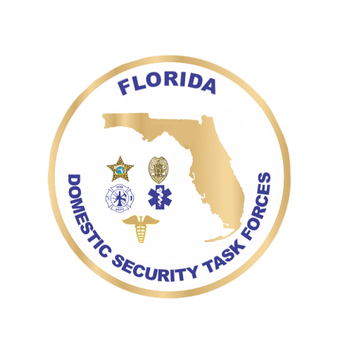
DOMESTIC SECURITY
OVERSIGHT COUNCIL
December 19, 2025 9:00 a.m. – 12:00 p.m.
Agenda
Welcome Ceremony Commissioner Mark Glass, FDLE
Roll Call
Approval of August Minutes

Discussion

Executive Order 25-244 Commissioner Mark Glass, FDLE

President Trump Executive Order 14362 Commissioner Mark Glass, FDLE

Relevant Florida & Federal Statutes Including, Commissioner Mark Glass, FDLE
but not limited to:
F.S. 775.30-775.35
F.S. 692.201-692.205
F.S. 812.141
8 U.S.C. 1101 et seq.
50 USC 1701 et seq.

Floor Open to Public Comment

Action item

Vote on Recommendations Made Commissioner Mark Glass, FDLE

