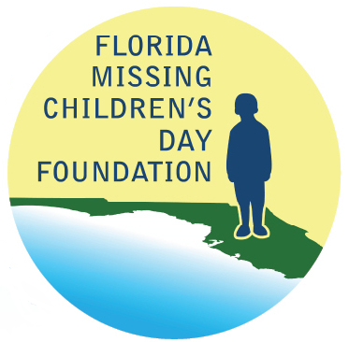

Florida Missing Children’s Day Foundation

Meeting Minutes

Conference Call – 11 July 2019

In Attendance

- Foundation Members:
  - Lauren Adams
  - Joyce Dawley
  - Ed Dean
  - Charlotte Jerrett
  - Pamela Marsh
  - James Previtera
  - Jon Shaw
  - Kenneth Tucker
  - Forrest Van Camp

- FDLE Members:
  - Brendie Hawkins
  - Erin Rounds
  - Craig Schroeder

Minutes
- Welcome and Introduction
  - Welcome and introduction from Foundation President Ken Tucker. The main purpose of today’s meeting is to talk about the August 5, 2019, meeting and event at the Tampa Bay Rays baseball game.

- Accept Previous Meeting Minutes
  - Motion made to approve the previous meeting minutes dated June 4, 2019, as presented. Motion seconded and approved.

- Treasurer’s Report
  - Foundation Treasurer Charlotte Jerrett presented the Treasurer’s Report dated July 9, 2019. More donations are starting to come in. Per discussions with Florida Department of Law Enforcement (FDLE) member Craig Schroeder, the donations coming in are on-track to cover expenditures.
  - Charlotte created a “requests for proposals” letter to send to audit firms for full audits of the Foundation account. The letter has been given to Craig for FDLE staff and general counsel to review before sending out to audit firms in the next couple of days. Upon research, a full audit may cost between $5,000 and $10,000. There are other types of reviews that could be completed but would not include a full audit.

During discussion of the audit, Foundation Board Member Ed Dean stated that a review should be sufficient for the amount of money that the Foundation handles. Charlotte will add a request for two quotes to the “requests for proposals” letters – one for a review and one for a full audit. Foundation Board Member Pamela Marsh will reach out to her Certified Public Accountant (CPA) contacts to request assistance with a review or audit of the Foundation account before the “requests for proposals” letters are sent.

Motion made to spend up to $2,500 to complete at least a review of the Foundation account. Motion seconded and approved.

- Rays Baseball
  - Plans are being made for a ceremonial first pitch at the Tampa Bay Rays baseball game on August 5, 2019, to honor the Florida Missing Children’s Day (FMCD) poster and essay contest winners. Prior to the game, there will be a Foundation Board meeting and a tour of Tropicana Field. Per Ken, FDLE staff met with the FDLE Commissioner who has directed staff to send letters inviting the Governor and Cabinet to the game as well as the police chiefs and sheriffs of Hillsborough and Pinellas Counties.
  - Foundation Vice President James Previtera is setting up and scheduling the day’s events. The Foundation will first meet in the Executive Conference Room from 4:00 pm to 5:00 pm. After the meeting, James will take the Foundation on a tour of Tropicana Field. The gates will open to the public about 5:40 pm. The Foundation can make their way to Suite EEE to watch the first pitch at 6:49 pm. The award winners on the field will include the FMCD essay and poster winners accompanied by the human trafficking investigator, and possibly other local law enforcement winners. Craig will have a table inside the main gate to promote FMCD to the public.
  - Per discussions that Ken has had with FDLE general counsel, Foundation members are not bound by the same code of ethics requirements as state employees. Ed requested FDLE general counsel send a letter or email to Foundation members stating the requirements of Foundation members.

- 2019 FMCD Strategy
  - Ken would like follow-up solicitation letters sent out by the end of July. Foundation Secretary Lauren Adams will work with Craig to make changes and send the letters out.
  - Lauren and Craig will also work out the logistics of sending out this year’s FMCD sponsorship invite letters and thank you letters.

- Additional Items
  - None

Motion made to adjourn meeting. Motion seconded and approved.

Adjourned

Florida Missing Childrens Day Foundation
Treasurers Report
July 9, 2019

May 31, 2019
Balance | $19,083.42
Donations | 10,750.00
Expenses | (1,100.00)
July 9, 2019
Balance | 28,733.42
Expenses Not Posted | 0.00
June 30, 2019
Available Balance | $28,733.42

