**Florida Missing Children’s Day Foundation**

Meeting Minutes

Conference Call – 18 May 2021

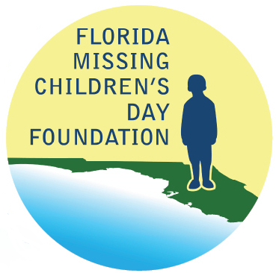

## In Attendance

* **Foundation Members:**
  + Lauren Adams
  + Joyce Dawley
  + Ed Dean
  + Charlotte Jerrett
  + Pamela Marsh
  + Jon Shaw
  + Kenneth Tucker
  + Forrest Van Camp
* **FDLE Members:**
  + Chad Brown
  + Ashley Bullard
  + Brendie Hawkins
  + Monica Mora
  + Mike Phillips

## Minutes

1. Welcome
   1. Welcome and introduction from Foundation President Ken Tucker.
2. Previous Meeting Minutes
3. Motion made to approve the previous meeting minutes dated July 9, 2020, as presented. Motion seconded and approved.
4. Treasurer’s Report
   1. Foundation Treasurer Charlotte Jerrett presented the treasurer’s report dated May 10, 2021. In 2019, the Foundation took in around $27,000 in donations, but in 2020 only around $15,000 was received due to the COVID virus. The 2020 Florida Missing Children’s Day (FMCD) event was held virtually resulting in approximately $9,000 spent which is well below the normal event expenditures of $23,000. As of May 10, 2021, the Foundation’s available funds are $34,411.65 including approximately $9,000 in donations received for this year’s event.
   2. FDLE members Brendie Hawkins and Ashley Bullard are moving forward with sending out the second round of donation letters in June. Ken expressed some concern that if donations continue to go down, we may not be able to fund future events. Ken is considering making presentations at the Florida Sheriffs Association and Florida Police Chiefs Association to promote FMCD.
   3. Foundation Secretary Lauren Adams has received inquiries from agencies about donating online, and she directed them towards the PayPal link on the Foundation website. At this time, it is not clear who has access to the PayPal account or if donations are automatically deposited to the Foundation bank account through the PayPal link. Brendie and Ashley are finishing up a new website for the Foundation that will have the capability to send donations directly to the bank account. They will check with Foundation member Joe Martinez about the PayPal access since he is maintaining the current Foundation website. They are also working to transfer the domain www.fmcdf.org from his ownership to the Foundation.
5. FMCD updates and Changes
   1. Due to construction at the capitol complex blocking the school bus loading/unloading zone, there will be no safety fair at this year’s FMCD event. Instead, FDLE is participating in Safe Summer, a joint project with the Tallahassee Police Department and the Leon County Sheriff’s Office. Safe Summer will take place on June 5th at the North Florida Fairgrounds in Tallahassee. FDLE will be there to promote FMCD and the Missing Endangered Persons Information Clearinghouse (MEPIC) by giving away promotional items and answering questions. Stephanie White with the MEPIC Advisory Board has agreed to bring her tracking dogs and the Child Abduction Response Teams (CART) coordinator and FDLE’s mobile command center will be in attendance. Per Brendie, FDLE’s intent is to return the safety fair to the actual FMCD ceremony in subsequent years, but if Safe Summer is successful, they may continue the regional event and also add regions outside of Tallahassee. Assistant Special Agent in Charge (ASAC) Chad Brown sent requests to the other ASACs in the state to find out if any other regions were planning events similar to Safe Summer. FDLE had discussions to do local/regional events at least for 2021; in 2022, they would like to plan another Tampa Bay Rays event.
   2. Brendie reported that the FMCD Ceremony costs will be reduced by approximately $3,000 this year because the catering and chairs required for the event will be reduced due to not having the children’s safety fair at the ceremony.
6. FMCD Quotes and Contracts
   1. Ashley reported that FDLE is moving forward with the FMCD ceremony and the usual contracts to make that happen with social distancing.
      1. Klassic Katering will provide breakfast and lunch for approximately $2,900 plus gratuity. Klassic Katering has agreed to add a cancelation clause reviewed by FDLE’s Office of General Counsel. If the ceremony date is changed, they will move the contract to the new date instead of refunding the deposit or other monies paid. Charlotte will send a deposit check.
      2. Production Support Group (PSG) will provide the stage and risers for approximately $2,510.50. They have also agreed to the cancellation clause. Charlotte will send a deposit check.
      3. Brendie and Ashley have a meeting planned with staff at the Double Tree Hotel to review their contract.
7. Proposed Budget
   1. Ashley reviewed the proposed budget for the 2021 FMCD event. The Foundation members voted on the budget in three parts: event budget, challenge coins, and safety event giveaways.
      1. Event budget - Motion made to approve the 2021 FMCD event budget for an estimated total of $16,695.00. Motion seconded and approved.
      2. Challenge coins - Motion made to approve the purchase of 500 FMCD Challenge Coins. Motion seconded and approved.

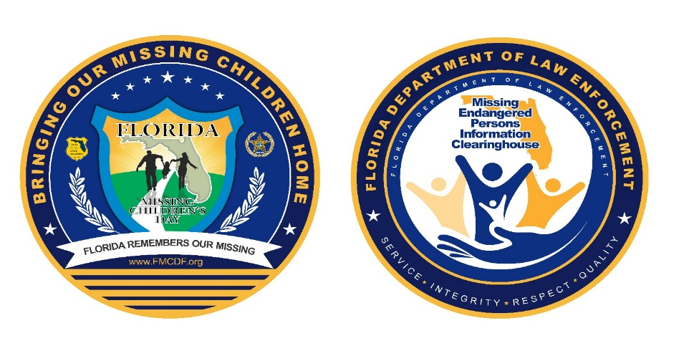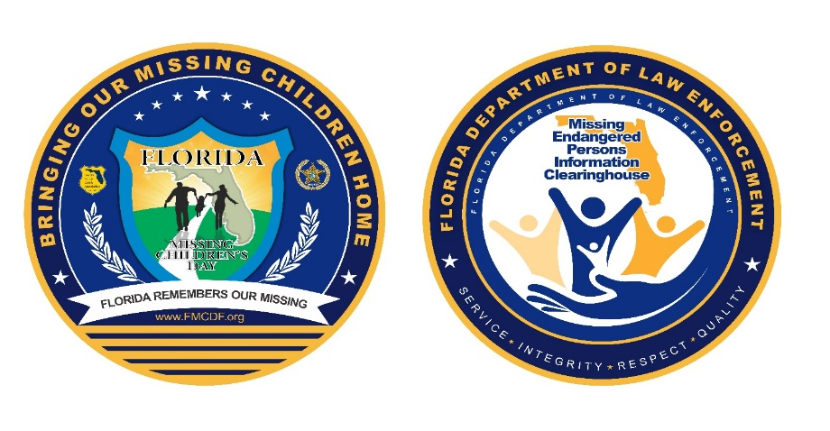

Figure 1: FMCD Challenge Coins

* + 1. Safety Event Giveaways – Ashley presented several items to use as giveaways for the children’s safety fair at Safe Summer. Brendie explained that the promotional products budget for previous events has come from a small FDLE promotional budget allocated to MEPIC, but that amount has been reduced so items will need to be ordered using monies raised through the Foundation.

Motion made that FDLE can spend up to $3,000 on giveaway items, excluding face masks, as long as the items have the FMCD logo on them. Motion seconded and approved.

1. Foundation Membership
   1. Ken offered Foundation board members the opportunity to be removed from the board if they choose or to make suggestions for additions. Board member Pamela Marsh took the opportunity to resign from the board because she is now the executive director of a non-profit and her biggest task for that organization is also fundraising. Thank you to Pamela and her service to the Foundation over the years!
2. Vote on Logo
   1. Foundation members voted on a joint FMCD and MEPIC logo for promotional giveaway items. Several logos were presented by FDLE.

Motion made to approve logo option #1. Motion seconded and approved.

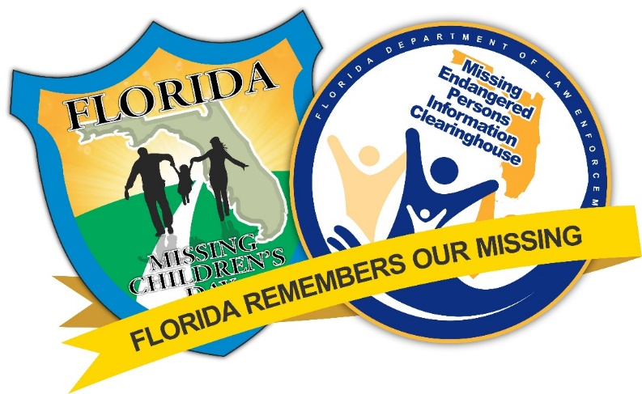

Figure 2: Joint FMCD & MEPIC Logo Option #1

Motion made to adjourn meeting. Motion seconded and approved.

## Adjourned

