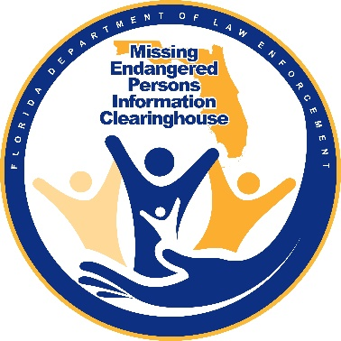
MEETING AGENDA

Florida Department of Law Enforcement

Missing Endangered Persons Clearinghouse

Advisory Board

Conference Call

4 May 2021

1:30 PM to 4:00 PM (EST)
Attendees-

FDLE:
SAC Phillips, Ashley Bullard, Monika Mora, Inspector Chad Hoffman, Pete Warren, Jon Roddenberry, ASAC Chad Brown, Mary Coffee, Brendie Hawkins, Jeff Dambly, Nancy Verhine

BOARD:
Assistant Chief Antonio Gilliam, David Brand, Hilary Sessions, John Pitta, Peggy Pitta, Gary Howze, Dr. Spence, Stephanie White, Floy Turner, John Robertson, Katherine Gomez

Welcome and Introduction of Roll Call

Approve 3/23 Meeting Minutes

- Meeting Minutes approved for 3/23

- AG: We can move forward with the challenge coin discussion.

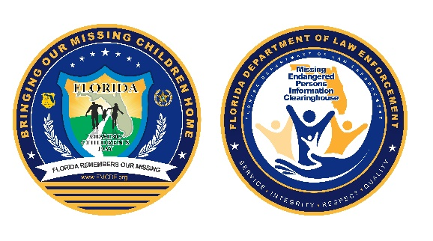
Challenge Coin update.

- AB: Same design as previously, but it’s changed to gold instead of black and blue due to printing.

- AG: Comments or questions?

Summer Newsletter
Article on the evolution of MEPIC.
Article on Session’s and Kesse’s bill that expanded MEPIC and what they did

- AG: Last call we talked about the evolution of MEPIC, a historical discussion. We talked about Sessions and Kesse’s bill. Hilary, anything to add in reference?

HS: Drew and Joyce Kesse and I approached Donna Uzzell because we wanted to raise the age on missing children from 18 under the existing law. Our children were 24 and 20 at the time of their disappearances, respectively. Donna suggested we follow the automobile insurance business model and we took it to 25. Young children under 25 are capable of doing anything and sometimes things happen in their lives that they have no control over. By raising it to 25, that increase covered college students and recent college graduates. We also wanted to add a requirement to collect DNA at the initial time of investigation. Donna suggested that we take it to 90 days to reduce the expense of collecting DNA and more importantly that many of the missing return in the initial 90 day period.
HS: We knew there were 40,000 undocumented and thousands of those are now in NAMUS, a repository of unidentified remains.
· HS: The Jennifer Kesse Tiffany Sessions Missing Persons Act was signed into law in 2008, Our law is also the underlying law which enabled the Governor to sign an Executive Order to establish the “Silver Alert” to help adults who are missing to get recovery help.
HS: The Silver Alert was codified into law two years later. The Silver Alert is like an Amber Alert; but for older people. It allows law enforcement to look for endangered adults. That’s where we came up with MEPIC. Missing Persons and not just Missing Children.
· AG: Any questions why we did what we did?
· AG: Thank you for your efforts that led to needed legislation and saving lives. I look forward to reading it.
· HS: I also worked on the Luring and Enticing Law which is one of only two laws nationally (the other is in Ohio) to be able to arrest a perpetrator of an attempted lure or enticing a child for an abduction. The next case was to collect DNA on a felony arrest. Since the law was passed in 2009, it took 9 years to cover all existing and any new felony cases; but by 2017 all felony cases now have DNA on file. This law was challenged in court and I was on the Amicus Brief when it went to SCOTUS, the US Supreme Court, SCOTUS which upheld the right to contain DNA on a felony arrest.
· AG: Anything else for Hilary?
Article highlighting FMCD.
- AG: We are looking for volunteers to write an article about their experience with Florida Missing Children’s Day.

- John Robertson (JR): I would be interested.
Update on Legislature Session.
- AG: Legislation update?
- AB: As soon as session is done, it’ll be in the next newsletter.
- Brendie Hawkins (BH): As soon as it’s finalized it will be complete because it just ended and they’re talking about a special session.

Myths/Misconceptions About Reporting/Receiving a Missing Person Report.
- AG: Any questions or replacement of a more prevalent myth?
- AG: Any other misconceptions to add to the next newsletter? For every newsletter we can add new points.

- N/A: I appreciate them being in there. They sound great.
- AG: We’ll move forward with those and work on the next slide in our in-person meeting, or the session after that.

- N/A: We should include best practices for parents about child trafficking and predators.

- AG A previous meeting comment made was about creating a FAQ on the MEPIC site to address what law enforcement should be doing in a missing case. Like “these are the standards agencies, law-enforcement and sheriff’s offices, need to abide by. ”FDLE heard the Board and is considering this idea.

- AG: Anything else anyone would like to see in this article, or FDLE can draft a list for child traffickers and predators.

- HS: One of the issues with missing children, the biggest problem was finding a place to put the child away from the predator if they’re trafficked, and it’s not always with the family because they’ve been trafficked by their own family.

- HS: Look at lockdown facilities to protect the child and keep the predator away.

- AG: That is an issue that law enforcement deals with.

- Katherine Gomez (KG): Forward-facing or back-facing. One of the items we run into when there are minors with experiencing trafficking is that sometimes the child doesn’t present as a sympathetic victim, and so calls to the child abuse hotline are not made. They need to be investigated as child abuse. As a myth buster, make sure if you encounter a child it would be to call the abuse hotlines for the CPIS to begin their investigation.

- AG: After the summer newsletter, internally, we’ll put out things like that to educate police departments and sheriff’s offices. Well include Florida State statues related to those points pointed out to Sheriff’s Association and Police Chiefs Association.

- AG: So start thinking what we can add to human trafficking and educational articles.

MEPIC Advisory Board In-Person Meeting

- AG: Everyone should’ve received an email; please make your reservation under the FDLE block for Thursday June 10th. If you need a room for Friday night it’s June 11th, and email Ashley.

- AB: There’s no dot between my name in the email. AshleyBullard@fdle.state.fl.us

- AG: In the chat, request that email or Ashley can put it in the chat, but she needs the reservation confirmed.

- AG: I don’t know if we discussed if the meeting would be fully in-person or hybrid?

- AB: Hybrid. We’ll have a GoToMeeting virtual option.

- AG: For a quorum, do you need in-person?

- AB: We’ll have an email chain going to vote. You’d have to email me before or during the meeting.

- Dr. Kim Spence (KS): The 10th, not the 5th?

- AB: Friday, June 11th at 8:30 am at Staybridge Suites, 1600 Summit Lake Dr, Tallahassee, FL.

FMCD Award Nominations

- AG: We are missing awards for Combatting Human Trafficking, and School Bus Operator of the Year. Anyone have anything in mind?

- AB: We got a CHT award an hour ago. We have one now for that category.

- KG: Is the nomination made in the meeting or are we given paperwork to fill out?

- AB: We prefer paperwork, but with the information we can contact the agency.

- KG: I would like the paperwork. My nomination, detective Beth Bascom (?) is with Tallahassee PD.

- AB: I’ll reach out via email and include the information in the chat.

- AB: Currently we have:
  - 1 Young Hero Nomination
  - 1 Citizen of the Year Nomination (this one could also qualify for the Evelyn Williams Award)
  - 2 Jimmy Ryce K9 Trailing Team of the Year Nomination (1 additional one that is same as Citizen of the Year.)
  - 1 State Law Enforcement Officer of the Year Nomination
  - 1 Local Law Enforcement Officer of the Year Nomination
  - 1 LE Task Force Nomination
  - AB: We are missing the Combatting Human Trafficking Award and School Bus Operator of the Year.

- Peggy Pitta (PP): There’s no school bus nominee?

- AB: I reached out to Leon County three times and they haven’t responded.

- PP: What about the Tampa bus driver that saved the 4-year-old around December?

- AB: The garbage truck driver?

- PP: Yeah, not a school bus driver.

- AB: I asked Hillsborough and got no response.

- N/A: I’ll reach out to Leon County schools.

FMCD Billboard Image
- AB: FDLE has chosen and approved the final FMCD billboard image.
FMCD Safety Fair
- BH: We came up with alternatives for the Safety Fair. Ashley reached out to Executive Director of Community Affairs for any events planned for the Summer and Fall regarding children’s safety.

- BH: On June 5th, from 10 am to 1 pm, in conjunction with the Tallahassee Police Department and the fire station, there will be a “Leon Safe Summer” event. It’s outdoor, socially-distanced at the fairgrounds. The Leon County Sheriff’s Office will have special teams for presentation. President Ken Tucker of the FMCD Foundation agreed that the Foundation could be a sponsor for the event. We have the opportunity to set up booths for MEPIC and FMCD. Stephanie White will come and bring her bloodhounds.

- BH: It’s the first alternative event to the Safety Fair. Safety Fair was cancelled due to challenges with Covid and construction. It was decided the ceremony was more important to have for the victim families.

- AG: Awesome news. Thank you, Stephanie.
- Stephanie White (SW): Monticello PD may be getting a puppy. I told them they have socialization training that day, so I’ll keep you posted. E.E. Eunice is retiring June 1st.

- AG: Anything else?

- AG: Motion to adjourn.

- AG: Are there no more virtual meetings before the in-person?

- AB: Correct. The next meeting is in person.

- AG: Safe travels; motion to adjourn.

- N/A: Second.

- Brian Moore (BM): Second.

Adjournment

