Tall
MEPIC Advisory Board
Committee Meetings Conference Call Minutes

Tallahassee, Florida
14, September 2020
12:30 PM – 2:30 PM

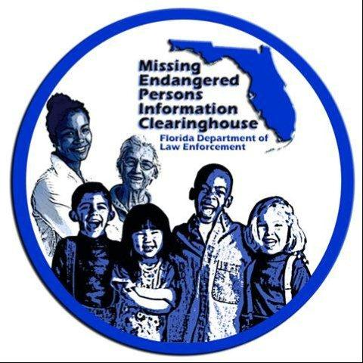

Attendance
- Dan Campbell
- David Brand
- Floy Turner
- John Pitta
- Peggy Pitta
- Julie Collins
- Antonio Gilliam
- Bill Corfield
- Bob Bedford
- Karen Mazzola

FDLE Members
- Chad Brown
- Ashley Bullard
- Zachary Durrett
- Brendie Hawkins
- Jon Rigsby

Minutes
- Dan: Glad everyone could come. Hope everyone enjoyed the ceremony this morning. Kudos to the ceremony team who put it together.
- *discussion of how people felt about the ceremony*
- Overall well done.

- Floy: Excellent. Like how it brought in lots of other people to involved plenty of others. Extremely well done. Governor and first lady were wonderful.
- Dan: Enjoyed getting to see more of the children.
- Brendie: We’re considering adding the video portion as something we could do at the sponsor breakfast or at the ceremony before it starts. We agree it’s a very impactful piece. 4.6k views on the Facebook feed as of right now.
- Mike Phillips did a great job keeping everyone’s story straight and making it flow.

- Julie: Opening speakers repeated themselves.
- Brendie: We agree, especially with the statistics.
- Dan: Having a recorded message from the governor, even a brief acknowledgement, is very powerful. It is noticed when he’s missing.
- The Pitta’s: Do we ever provide recognition or thanks to the governor or first lady’s office?
- Brendie: That’s not something we’ve ever done. We could draft something and have Dan sign it.
-Conclusion of the ceremony having the video and the scroll would be nice. I know we are limited in space on easels, but I thought it was very powerful to have the video.

- Chief Gilliam: Good feedback. I missed the ceremony due to ongoing events here. But now we have a template for going forward.
-Challenge Coin for the board ever discussed?
- Brendie: ASAC Brown has a challenge coin for our Bureau that has been drafted, but the initial print and design process is expensive. We have our coin almost finalized, but there’s been nothing done on something specific for the Foundation.
*further discussion on challenge coin and design possibilities*
- Brendie: We do have Saeedeh Posey in house who could help if people want to take on this issue.
- On one side we could have the MEPIC/FMCD logo, but it would be very nice to have a smaller version of the poster winner on the other side.

- Brendie: We made magnetic bumper stickers of the poster winner this year. We could have one logo on one side, the missing children’s day shield on the side, or we could do quarters that allude to FMCD, the advisory board, etc.
- Dan: Perhaps we should put this on the agenda for the next meeting.
*further challenge coin discussion, suggestion of one coin that could be reused*
- Brendie: Vendor deposits have been held for next year and will remain in effect. Theme parks declined to provide gift packages this year. We provided gift cards instead. We have the outline of the FMCD logo as a possible idea for the challenge coin.
- Dan: License plate income?
- Brendie: That’s a very heavy lift. I believe they require a statutory change. They might be open to allowing us, but in previous years, the priority was on getting changes made that would allow the foundation to accept money from non-law enforcement sources.
- Chad: Minimum order is about 250 coins and level of detail determines the cost. Cost can be $5-8 per coin.
- Dan: Let’s put this on the agenda for the next meeting and see if we can develop a handful of options involving logos, phrasing, etc.
- Dan: Do we want to discuss the newsletter?
- Brendie: We need to know what needs to get done and get assignments.
- Dan: Dr. Spence might have been the one who suggested it, but he asked if we could have a section on different board members and what they do on the board and outside of it. Other sections would primarily focus on the award winners.
- Brendie: We have the photos of all the award winners already, so that’s entirely possible.
-Would it be possible to spotlight Craig for all of the work he did?
- Dan: I think that’s a good idea and could be the member spotlight section.
- Brendie: Perhaps a special thanks section. We could have families write essays on what FMCD means to them.
- Ashley: Alvarez family may want to do something. They’ve been attending for many years and her body was recently found.
- Brendie: There may be a language barrier there. We could ask them for a letter in their home language and then have it translated. I’d also like to take a moment to recognize Ashley’s hard work on the video.
- David Brand: PoliceOne has created training courses for thousands of officers and deputies. We thought there might be an opportunity to create a video about the mission of the organization or missing children in general.

Adjourn

