Tall
MEPIC Advisory Board
Committee Meetings Conference Call Minutes

Tallahassee, Florida
23 July 2020
12:30 PM – 2:30 PM

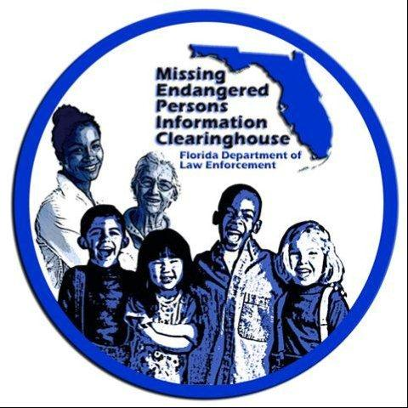

Attendance
- Bob Bedford
- David Brand
- Dan Campbell
- Katherine Gomez
- Cpt. Randy Head
- Jessica Janasiewicz
- Kristin Litteral
- Karen Mazzola
- Sheriff McNeil
- Travis Paulk
- John Pitta
- Peggy Pitta
- Hilary Sessions
- Kim Spence
- Floy Turner
- Stephanie White

FDLE Members
- Chad Brown
- Ashley Bullard
- Mary Coffee
- Brendie Hawkins
- Mike Phillips
- Craig Schroeder

Minutes
- Dan Campbell (DC): I just want to welcome everyone and thank all of our Board members in law enforcement.
- DC: Craig, do you have an update on the Rays event?
  - Craig Schroeder (CS): Yes, as I’m sure you all can imagine, the event will not happen this year, but we are planning on continuing this new tradition next year.
- CS: The next big news we have is that we have decided, due to COVID-19, to cancel the in-person portion of Missing Children’s Day and move the event to a virtual platform. The idea is to have portions we will record live, specifically the Governor’s statements and the presentation of the awards. The award winners will not be present, and they will have been given their award before the event and we will play photos and/or video of them as SAC Phillips presents the award.
  - CS: We also plan to make sure there is a Time of Remembrance portion where we can be sure to highlight all of the missing children in Florida.
  - HS: Will our hotel be cancelled?
    - Brendie Hawkins (BH): We can do that for you.
  - BH: And we just want to assure everyone that we will put a strong focus on the Time of Remembrance.
  - Bob Bedford (BB): We might want to think of pre-recording the governor’s portion of the ceremony because it’s crazy times and he might not be able to be at a specific place at a specific time.
    - CS: We will be as adaptable as possible to try and make this happen; and we are already working with his office on ideas.
  - Kim Spence (KS): Should we have still photos of all children to play during the Time of Remembrance.
    - CS: Yes, we will be doing that.
  - John Pitta (JP): Any thought of having the governor send a letter to the families?
    - CS: Great idea.
    - BH: I like the idea as well we can start working on a draft.
- DC: Looking towards the second issue of the newsletter maybe we can consider some topics for the article.
  - Stephanie White (SW): Didn’t we want to focus on the FMCD winners.
    - CS: Yes.
  - KS: Maybe we could have a section from the perspective of an award winners; just a quick one or two questions.
    - BH: Great idea.
  - KS: Can we keep doing the board member spotlight?
    - CS: Yes, definitely.
- CS: Also, just as a quick update because I know several of you have asked, the Commissioner’s Awards that Board recommended at the last meeting are still awaiting final approval from the Commissioner’s office.
- Mike Phillips (MP): Thanks to everybody for their input and I think it will make this event special. One option was to cancel or delay it but I was against that idea and want to give it a special touch. I ask everyone to not stop with their creative ideas.
- DC: Does anyone have anything else?
- DC: Well with that, I think we can adjourn.

Adjourn

