Tall
MEPIC Advisory Board
Committee Meetings Conference Call Minutes

Tallahassee, Florida
18 June 2020
12:30 PM – 2:30 PM

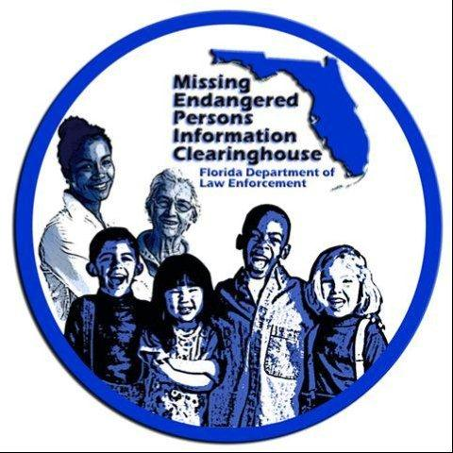

Attendance
- Dan Campbell, Chairperson
- David Brand
- Julie Collins
- Bill Corfield
- Cpt. Tim Enos
- Asst. Chief Antonio Gilliam
- Jessica Janasiewicz
- Karen Mazzola
- Sheriff Walt McNeil
- John Robertson
- Hilary Sessions
- Susan Smith
- Floy Turner
- Stephanie White

FDLE Members
- Chad Brown
- Ashley Bullard
- Mary Coffee
- Jeff Dambly
- Brendie Hawkins
- Rob Moon
- Mike Phillips
- Craig Schroeder
- Pete Warren

Minutes
- Craig Schroeder (CS): Before we begin, let me do a quick roll call and make sure we have a quorum.
- Dan Campbell (DC): I want to welcome everyone and thank them for joining us.
- CS: Also, can I ask everyone to mute their phones when they aren’t speaking? As you know our last few calls have had some technical difficulties and I think part of it might be feedback from idle phones.
- DC: Right now I’d like to calls for a vote to accept our previous meeting minutes from our February 28th meeting.
  - Peggy Pitta (PP): Motion to accept the minutes
  - DC: Minutes accepted.
- CS: Before we begin the voting process, I just want to mention that we got a nominee in late and I want to see if the Board wants to accept the nomination.
  - DC: What if we vote for everything now except the category with the extra nomination then we can vote on that one by e-mail tomorrow.
  - CS: That sounds good.
  - Stephanie White (SW): I just want to take a minute to speak about some of the nominees in the K9 Trailing Team category?
  - Floy Turner (FT): The Miami team has won an FMCD award before recently, do we know which category?
    - CS: It was the Team/Task Force.
  - DC: Could a team be considered for the award?
    - MC: Yes, they aren’t restricted.
- DC: Okay, well if no one has any more questions on the nominees let’s all e-mail our votes to Craig.
SOME MEETING MINUTES WERE MISSED, AS THE TAKER OF MINUTES WAS ALSO COUNTING THE VOTES
- DC: We also need to suggest possible nominees for the Commissioner’s Awards. Craig what were those again?
  - CS: They are the John and Reve Walsh Award, the Evelyn Williams Memorial Award, and the Commissioner’s Award.
    - PP: I’d like to put Jamie Meeks forward for a Commissioner’s Award.
  - FT: Also, put the Miami Dade Squad up for a Commissioner’s Award.
  - FT: Also, Milo Thornton might be a good suggestion for one of those awards.
  - CS: Peggy could you send me a write up on Jamie and Floy could you send me a write-up on Milo?
- DC: Next is influencing state-wide conference, I know most of them have been cancelled or postponed.
  - KM: Update on cancelled conferences.
  - DC: What about ICAC conference in December?
    - BH: As of now we are still going forward with that conference as planned.
- DC: Next I’d like to Introduce Ashley Bullard from MEPIC to give the Board a brief MEPIC presentation that they can use when speaking at conferences.
ASHLEY BULLARD PRESENTS MEPIC PRESENTATION
- Ashley Bullard (AB): Are there any questions about the MEPIC presentation?
  - Karen Mazzola (KM): How long is it?
  - AB: It can be adjusted, but I designed it to be about 10 to 15 minutes to add to your existing presentations.
  - Bill Corfield (BC): Can we put a link to the AB site at the end?
    - AB: Yes definitely.
  - DC: Should we take out the word “in person” because of COVID?
    - AB: Yeah, I can do that.
  - KM: Should we include all of our Award categories so people know what they can nominate their co-workers for?
    - BH: We can add that.
- DC: Craig, can you announce the winners?
- CS: Certainly, winners are:
Award | Honoree | Office
Local LE Officer of the Year | Detective Justin Murray | Clearwater PD
 | Detective Maria Beaver | Clearwater PD
Task Force/Team of the Year | Human Trafficking Squad | Miami-Dade Police Department
 | Lt. Luis Poveda
 | Sgt. David Quintas
 | Detective Jessica Bermudez
 | Detective Johnpaul Valentin
 | Detective Chaz Felder
 | Victim Advocate Elba Suarez
Combatting Human Trafficking | Officer Jeffrey Arbogast | Margate PD
Award
Citizen of the Year | Rosler Pierre | Orange County
School Bus Operator of the Year | Twanna Meeks | Leon County
K-9 Trailing Team of the Year | Deputy Frederick J. Gimbel II & K9 Holmes | Flagler County SO

  - DC: Motion to accept
    - SW: Motion to accept winners.
    - BC: Motion seconded.
- DC: Ok, and how can we formally vote to accept the last category via an email vote?
  - JD: If you all decide to do it this way, I would say that when Craig notifies of the winner if everyone responds to Craig saying they accept then that will work.
- CS: A quick update on the Facebook page, our command staff has approved the page and the procedures, so we just need to make sure to establish procedures on how to post.Update on Facebook page.
- CS: Our newsletter has been finished and distributed.
  - DC: When do we want to put out our next newsletter?
  - KM: Maybe have a draft ready by our next meeting? And we can highlight this year’s winner.
- Pete Warren (PW): Gives the MEPIC update.
  - PW: MEPIC has adjusted for COVID and continues to manage alerts 24/7.
  - PW: We are using a new vendor for our alerts.
- Rob Moon (RM): Gives update on the sex offender registry.
- DC: Does anyone have anything else?
- DC: If not, we can adjourn.
  - John Pitta (JP): Motion to adjourn.
  - Jessica Janasiewicz (JJ): Motion seconded.
  - DC: Meeting adjourned.

Adjourned

