Tall
MEPIC Advisory Board
Committee Meetings Conference Call Minutes

Tallahassee, Florida
27 January 2020
12:30 PM – 2:30 PM

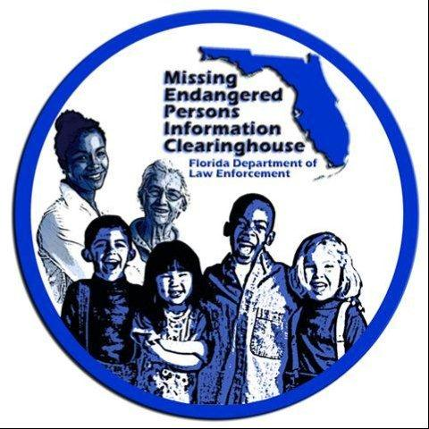

Attendance
- David Brand
- Ashley Bullard
- Dan Campbell
- Julie Collins
- Bill Corfield
- Tim Enos
- Brendie Hawkins
- Jon Rodenberry
- Craig Schroeder
- Pete Warren

Minutes
- Craig Schroeder (CS): Hi everyone, I just want to reiterate and apologize for the call last time; we share a GoToMeeting Account and you can only have one call at a time, and someone scheduled another call without checking and when they started their call it disconnected ours. We were able to secure a new line, but the phone number and the access code were different which meant if we all called back right then it would no longer be a publically noticed meeting.
- Dan Campbell (DC): Craig, did anyone follow-up with you about the conference and the possibility of speakers?
  - CS: Yes, we currently have about six perspective speakers: Kim Spence volunteered, as did Travis Paulk. We are also reaching out to Lori Smith who spoke with the Board a few years back. And Bill is in contact with a few others to present sessions.
- DC: Bill were you still thinking we’d do the conference split down the middle, half aimed at the general public and half law enforcement?
  - Bill Corfield (BC): Yes, I think that would be best. We have the rooms secured right?
  - CS: We have one room in the House building secured and I am working on the second, but it should not be a problem
  - BC: And what time were you think we start? 1?
    - CS: I think that’s a realistic goal. The ceremony will end at 11:15, so if we needed to kick the trainings off at noon I think we could, but the 1:00 time would give us a nice cushion.
  - Brendie Hawkins (BH): And we could start a new 50 minute session on the hour with a 10 minute break in between.
  - BC: I’d also like to try and get one or two other presenters on the LEO side of things.
  - BH: Maybe we can get Mike Duffey who is our new ASAC and is a subject matter expert in internet crimes against children. He does presentations like this all the time.
  - BC: That would be great
- DC: Well it sounds like everything is coming together and hopefully by our meeting in February we can have the location and presenters secured.
  - CS: And we can use that time to discuss how to raise awareness of the event.
- DC: Craig do we have any updates on the PSA?
  - CS: I know Mike Vasilinda was working on a second PSA idea, I can follow up with him and find out.
- CS: And for the Facebook page, the page is created and we are going to send that through FDLE’s PIO office before we make it public and usable.
- DC: Okay, does anyone have anything else?
- DC: Okay, in that case we can adjourn.

Adjourned

