Tall
MEPIC Advisory Board
Committee Meetings Conference Call Minutes

Tallahassee, Florida
16 January 2020
12:30 PM – 2:30 PM

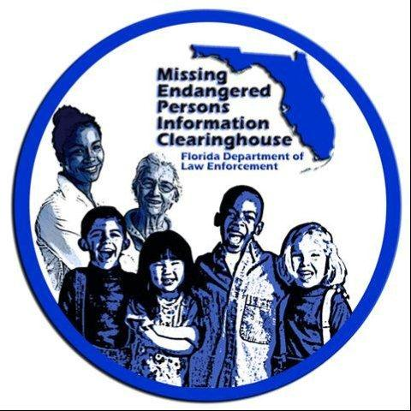

Attendance
- Jasmine Armstrong
- Bob Bedford
- David Brand
- Ashley Bullard
- Dan Campbell
- Julie Collins
- Bill Corfield
- Chief Antonio Gilliam
- Brendie Hawkins
- Walt McNeil
- Lt. Derrick Rahming
- John Robertson
- Jon Roddenberry
- Craig Schroeder
- Hilary Sessions
- Floy Turner
- Pete Warren

Minutes
- Dan Campbell (DC): Roll call
- DC: Craig, can you provide us an update on where we are on the 2020 Missing Children’s Day.
  - Craig Schroeder (CS): Sure. We have the date established, it will be on Monday September 14th.
  - CS: We already have the space reserved.
  - CS: In addition, the nomination forms for the 2020 awards are up on the MEPIC site. We won’t start pushing the nominations to LEO agencies until late March, but the nomination forms are available if anyone should need them.
  - CS: Also, we are underway with both the poster and essay contests.
  - DC: What is the representation of kids across the state for those contests.
    - CS: We break up the essay contest by the seven regions FDLE uses, and we usually have pretty solid representation across all seven. Of course there is always more submissions from Miami and Tampa areas.
- Bill Corfield (BC): Did we decide on the training for 2020?
  - CS: We decided at the last meeting to do it all on site at the Capitol Complex and we have those rooms we use for the rain plan to conduct the sessions
  - BC: And did we decide to do it all one track or split between law enforcement and citizen.
  - Antonio Gilliam (AG): I think we decided to split. I think we need to decide who would be able to speak? If you are able, please send something to Craig or if you know of someone who might be able to—like some of the people recommended on our Subject Matter Expert List—speak please send their information to Craig.
  - AG: Craig, do we have at least four rooms?
    - CS: We currently have two of the large rooms.
  - AG: So I think everyone on the Committee needs to say whether they can present? Or check to see if your SME can present.
  - AG: And we also need to know if we can use those rooms to 5:00 PM and we need to know how we can disseminate this information to those agencies attending.
    - CS: We are able to reserve the rooms for the entire day.
  - AG: And the last piece would be how we get that information out to the general public in Tallahassee for the civilian training.
    - BC: Is that something that FDLE can assist?
    - CS: You mean with spreading the word?
    - BC: Yes.
    - CS: I think we can work with people in town.
    - John Robertson (JR): There’s also the United Partner of Human Services who can help once we have our elevator pitch. I think with their help we can definitely get the word out around town.
    - Floy Turner (FT): I would also look at the service organizations in town.
  - AG: So we need to verify those rooms and get those experts to commit to the topics.
  - AG: And if there’s something we can post to FDLE’s social media that would be great as well.
  - AG: Can we get the government rate from DoubleTree?
    - CS: I can ask.
  - AG: I’d say by our next in-person meeting we need to have the space figured out and our speakers confirmed.
  - DC: Following up on the training, John if we had a list of speakers by our February meeting, would that give you time to pitch it to your people to get the word out?
  - JR: Absolutely. And I’m going to pitch it to our state wide folks.
- DC: Craig can you give us an update on the newsletter?
  - CS: Certainly. We have a rough draft we’re working on right now and it is almost complete. The goal is to have a finished draft completed by the February 28th meeting so the Board can approve it and we can send it out in the early Spring.
AT ABOUT 2:45 PM THE CALL DROPPED; BECAUSE A RE-CONNECT WOULD REQUIRE A NEW NUMBER AND ACCESS CODE—AND THEREFORE NO LONGER ADHERE TO SUNSHINE REQUIREMENTS—THE DECISION WAS MADE TO ADJOURN THE CONFERENCE CALL.

Adjourned

