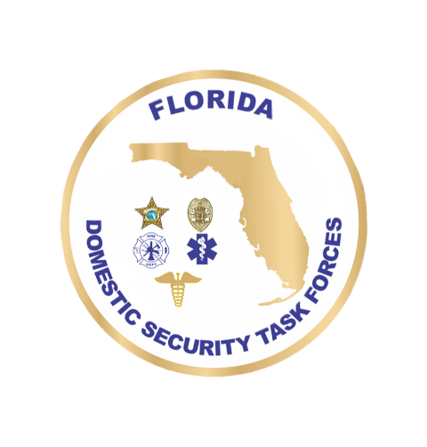**DOMESTIC SECURITY**

**OVERSIGHT COUNCIL**

**August 14, 2025 9:30 a.m. – 12:00 p.m.**

**Agenda**

Welcome Ceremony Commissioner Mark Glass, Roll Call FDLE

Approval of June Minutes

**Updates**

FY2025 NOFO Updates AC Mike Phillips, FDLE

**Action Items**

FY25 Miami UASI Project Presentations Chief Adrian Plascencia

FY25 Tampa Bay UASI Project Presentations Garry Lisiewski

FY25 Orlando UASI Project Presentations Captain Mitch Shaban

FY25 Jacksonville UASI Project Presentations Captain Sharaad Christopher

FY25 SHSP Project Presentations AC Mike Phillips, FDLE

**Calendar**

DSCG Focus Group Meetings September 9-11, 2025 Orlando, FL

DSCG Executive Board Meeting October 15-16, 2025 St. Petersburg, FL

DSOC Meeting November 18, 2025 Destin, FL