School Guardian Management System

Frequently Asked Questions

UPDATED September 9, 2024

* **When I click on the link provided in the letter, the page is unavailable. How do I get access**?

**Response**: The following alternative link is available if you experience difficulty accessing the SGMS login screen. At the login screen, please click on the “Request School Guardian Management System Account” and follow the screen instructions; see the picture below.

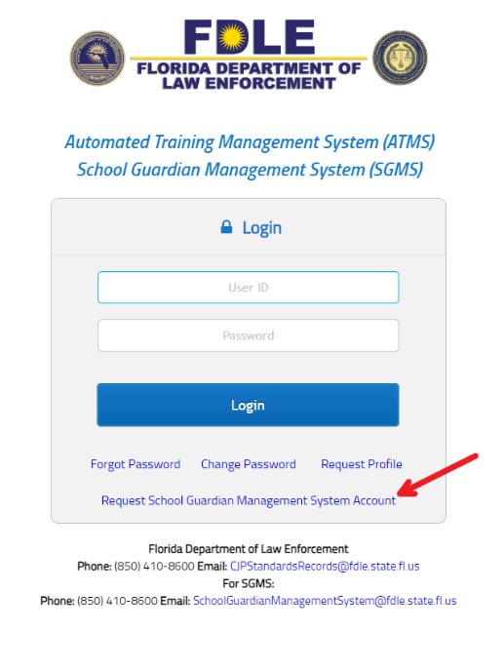

* **Our agency/county does not have any current Guardians. Is it still mandatory to submit a quarterly report indicating that we do not have Guardians or no training planned?**
  + **Response**: Yes, HB 1473 (s. 30.15, F.S.) requires you to report upcoming training quarterly. Each quarter, please notify us through the following email [schoolguardiantrainingcalendar@fdle.state.fl.us](mailto:schoolguardiantrainingcalendar@fdle.state.fl.us). If you do not have any training that quarter, please send notice of ‘no applicable training’ for that quarter. The following website is available to track school guardian training and provide reporting instructions for your convenience. <https://www.fdle.state.fl.us/CJSTC/School-Guardian-Training-Course-Calendar>
  + Also, please note that Sheriffs are required to notify FDLE within 30 days of certifying a guardian. Guardian certification will be reported to FDLE through the School Guardian Management System. Access is available [here](https://atms.fdle.state.fl.us/atms/shiroLogin.jsf) by clicking the “Request School Guardian Management System Account” and following on screen instructions.
* **I’ve logged into ATMS but do not see anything about the Guardians**.
  + **Response**: To gain access to SGMS, please go to the ATMS/SGMS login screen [here](https://atms.fdle.state.fl.us/atms/shiroLogin.jsf), click on the “Request School Guardian Management System Account,” and follow the on-screen instructions; see the picture below.

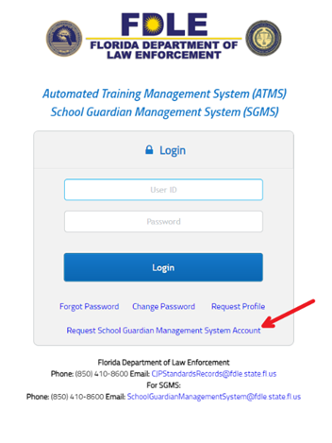

* **What is a** **School Guardian?**
  + **Response:** School Guardian is defined under s. 1006.12(3) and s. 30.15 Florida Statutes.
* **My private/charter/district school has no School Guardians. Do I still have to report?**
  + **Response:**If you do not have a School Guardian (as defined under s. 30.15 and s. 1006.12 Florida Statutes) employed with your school, then this requirement does not apply. However, should you choose to employ a School Guardian in the future, the reporting requirements of s. 30.15 Florida Statutes would apply.
* **I have a district guardian that is not assigned to a single school, how do I proceed?**
  + **Response:** For School District users, you can select [County name] District Office under Guardian Employment for guardians who are not assigned to a specific school.
* **I oversee guardians at multiple private schools, do I need separate accounts or can I manage all under the same account.**
  + **Response:** Yes, you can manage multiple schools from a single school user account. The top right of the SGMS has a settings icon, see below, that will allow you to select the multiple schools (manage schools) in which you have been granted access. Please send an email to [schoolguardianmanagementsystem@fdle.state.fl.us](mailto:schoolguardianmanagementsystem@fdle.state.fl.us) to request the multiple schools be added to your user account access, if the schools you need do not appear.

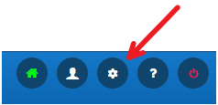

* **I have a security guard at my school, are we required to enter them into the system**. Anyone who has received a School Guardian Certificate under s.30.15(1)(k)3, F.S., must be reported to the Department of Law Enforcement through the School Guardian Management System by the issuing Sheriff’s Office. Starting September 1, 2024, and every February 1 and September 1 thereafter, each school district, charter school, and private school must report the following details for each school guardian: name, date of birth, and appointment dates. A school guardian, as defined in statute 1006.12(3), must be employed by the school. Those certified as school guardians by a Sheriff’s Office and contracted through a security company (school security guards, as defined in statute 1006.12(4)) will be able to enter their details into the system once it is updated. We will communicate the update to the schools once the update is completed.