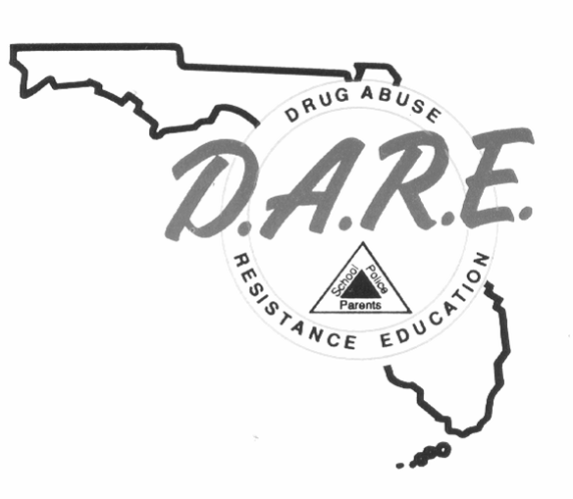
INVOICE FOR REGISTRATION
D.A.R.E. OFFICER TRAINING/CENTRAL FLORIDA
REGISTRATION FORM
JULY 24-AUGUST 4, 2023
Ocala/Marion County Sheriff’s Office

NAME (Print)_________________________RANK/TITLE______________________

AGENCY_______________________________________________________________

ADDRESS______________________________EMAIL_________________________

CITY__________________________STATE________________ZIP_______________

PHONE ( )_______________________ FAX ( )__________________________

Tuition (Full Time Students) $450.00__
Tuition (Recertification Students) $225.00_

Return Registration to: davidbullard@fdle.state.fl.us
FLORIDA DEPARTMENT OF LAW ENFORCEMENT
ATTN: Inspector David Bullard/D.A.R.E.
2331 Phillips Road
Tallahassee, FL 32308

