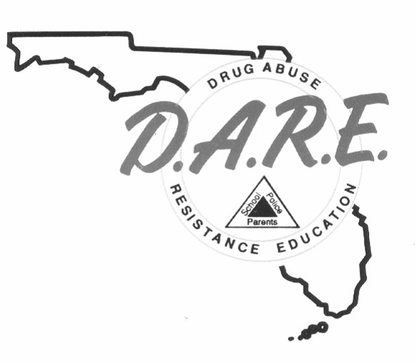
D.A.R.E. OFFICER TRAINING
REGISTRATION FORM

TRAINING DATES: June 3-14, 2024 LOCATION: LCSO, Tavares, FL

NAME (Print): _____________________________ RANK/TITLE: _______________________
AGENCY: ___________________________________________________________________
ADDRESS: __________________________________________________________________
CITY: ____________________________________ STATE: ________ ZIP: _____________ PHONE: (_______) _______ - _________ EMAIL: __________________________________
PLEASE SELECT A CLASS BELOW:
Full-Time Class (80 Hours): $450.00 Tuition
Recertification Class (40 Hours): $225.00 Tuition
Please return completed Registration Form to:

Florida Department of Law Enforcement Attn: David Bullard / D.A.R.E.
2331 Phillips Road
Tallahassee, FL 32308 Submit your completed registration form to David Bullard at DavidBullard@fdle.state.fl.us

