Advanced analyst training seminar
Location: | Hyatt Regency Sarasota
Date: | September 11-13, 2024 | 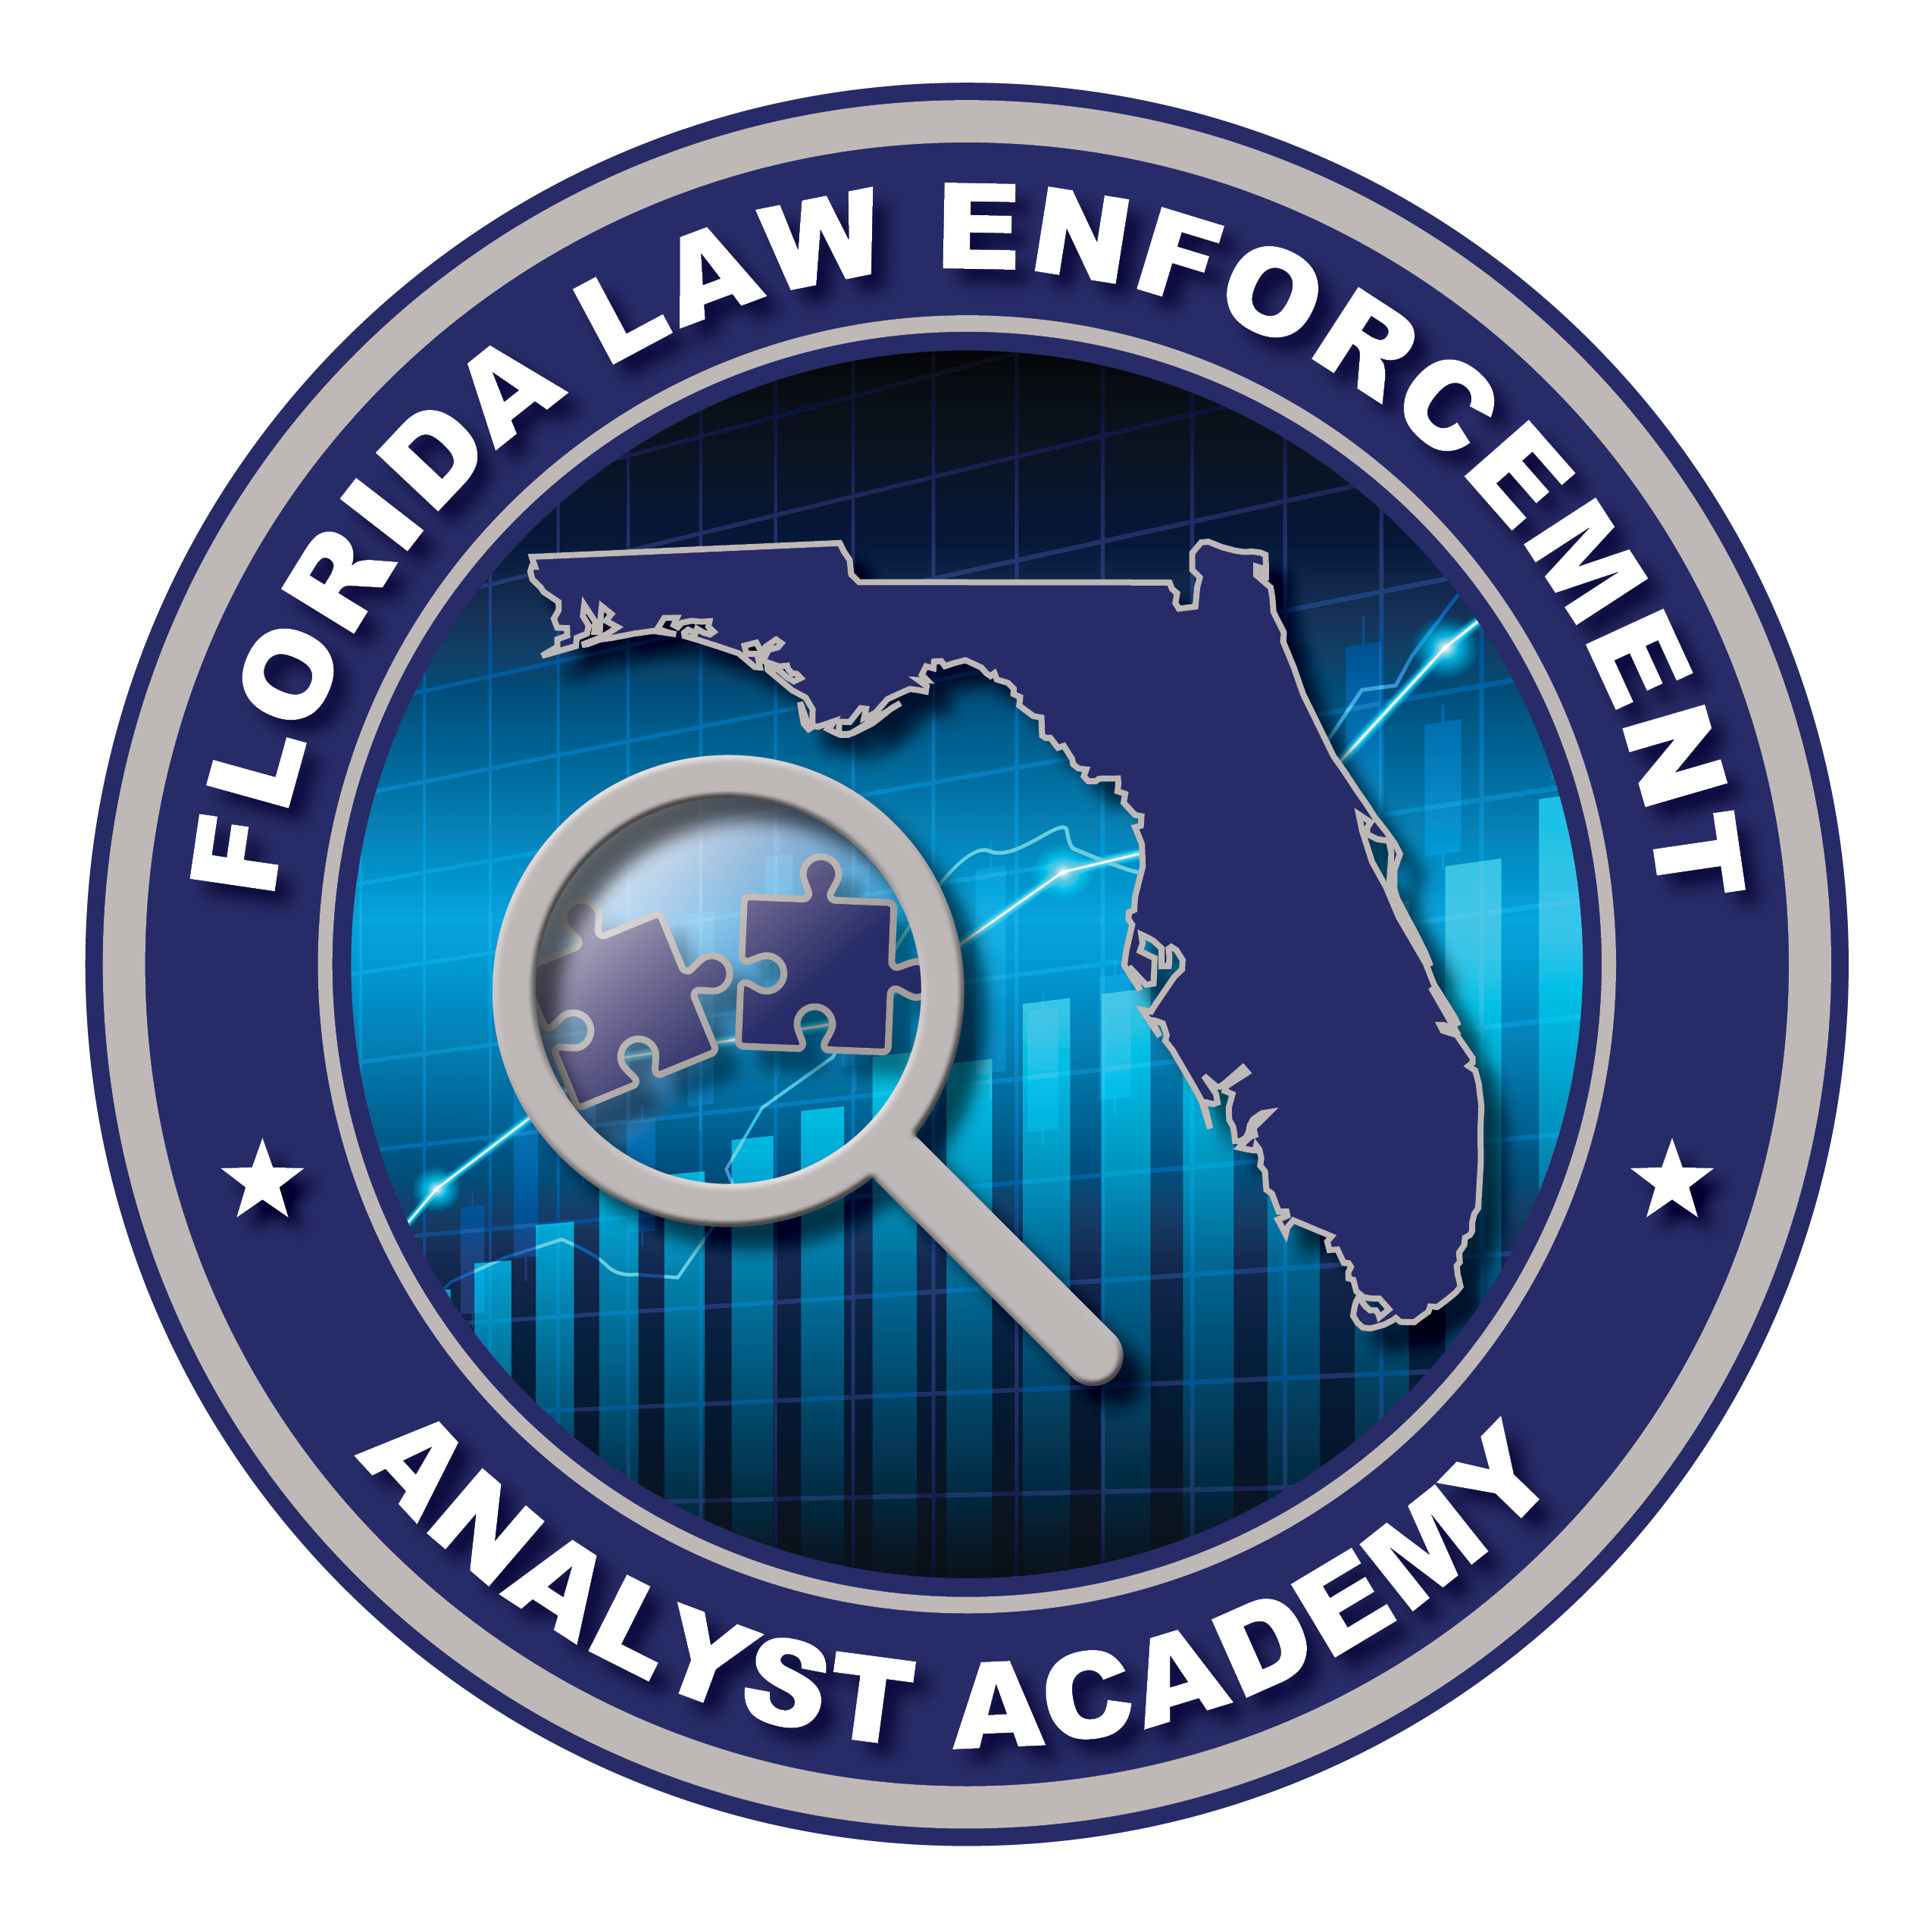
Time: | 8:00 – 5:00

Wednesday, September 11
 | 8:00 | Welcome | Kyle Christensen  Florida Department of Law Enforcement
 | 8:15-12:00 | Advanced OSINT Instruction  - Custom Search Engines and AI Enhancement  - AI in Investigations and Data Analysis  - Practical Tools and Techniques | Kirby Plessas  Plessas Experts Network, Inc.
 | 12:00-1:00 | Lunch
 | 1:00-5:00 | Advanced OSINT Instruction  - Custom Search Engines and AI Enhancement  - AI in Investigations and Data Analysis  - Practical Tools and Techniques | Kirby Plessas  Plessas Experts Network, Inc.

Advanced analyst training seminar
Location: | Hyatt Regency Sarasota
Date: | September 11-13, 2024
Time: | 8:00 – 5:00

Thursday, September 12
 | 8:00-12:00 | Advanced Excel Skills | Jennifer Scavotto  Seminole County Sheriff’s Office
 | 12:00-1:00 | Lunch
 | 1:00-5:00 | Oral Briefing Skills | John Shermetaro  Shermetaro Speaking

Advanced analyst training seminar
Location: | Hyatt Regency Sarasota
Date: | September 11-13, 2024
Time: | 8:00 – 12:00

Friday, September 13
 | 8:00-10:00 | Internet Crimes Against Children | FBI
 | 10:00-12:00 | The Analyst’s Role in Gang Investigations | Rob Mateo  Florida Gang Investigators Association  National Alliance of Gang Investigators Associations

