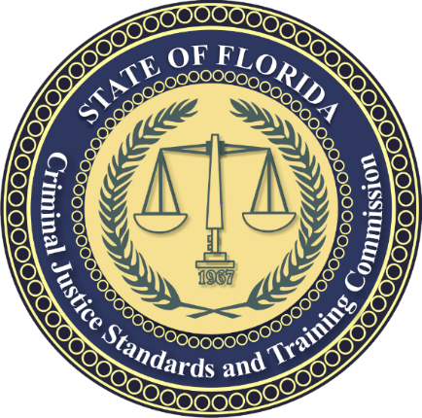**Criminal Justice Standards and Training Commission Meeting**

**Meeting Dates: October 27 - 30, 2025**

**Embassy Suites Orlando - Lake Buena Vista South**  
4955 Kyngs Heath Road  
Kissimmee, Florida 34746  
Front Desk: (407) 597-4000  
Front Desk Fax: (407) 597-4101

**Hotel Accommodations/Amenities**:  
The group rate is $169.00 per suite per night plus applicable state and local taxes. All guest suites are "run-of-the-house" unless stated otherwise. All suite rates are based on single/double occupancy. Guest suite types cannot be guaranteed and will be reserved on a first-come, first-served basis. If there are more than two guests, an additional charge of $10 plus tax per person per night will apply for each additional guest, up to a maximum of six guests per suite. All suites come with a mini-fridge and a microwave. Complimentary basic Wi-Fi is available in all guest suites, and there is a complimentary on-site fitness facility. All overnight guests will receive a complimentary evening reception from 5:30 p.m. to 7:00 p.m. and a made-to-order breakfast that is complimentary as well. Breakfast is available from Monday to Friday, from 6:30 a.m. to 9:30 a.m. On weekends, from Saturday to Sunday, breakfast is available from 7:00 a.m. to 10:30 a.m. The Citrus Room is where you can enjoy these amenities at your leisure. Group rate is available from October 26 – November 1, 2025. Rates are applicable three (3) days before and three days (3) after the group’s official meeting dates, subject to space and rate availability. Check-in time is 4:00 p.m., and check-out time is 11:00 a.m. Late check-out requests will be reviewed based on hotel demand a late departure fee of $50 per suite. Early check-in cannot be guaranteed. Please contact the hotel to ask about early check-in or late check-out. There is no resort fee. The cutoff date for making reservations is **October 5, 2025**. Reservations made after this date may not receive the group rate or room block. Please contact the CJSTC Meeting Planner, Cheryl Taylor, at [CherylTaylor@fdle.state.fl.us](mailto:CherylTaylor@fdle.state.fl.us) to include your first and last name and your arrival and departure dates.  
  
**Reservation**:  
Individuals can make, modify, or cancel all reservations online at <https://book.passkey.com/e/50937797> . To make a reservation by telephone, please call the Embassy Suites Reservations at 407-597-4000 and ask for reservations (be sure to mention group code **LAW**. Individuals can guarantee reservations with the first night’s pre-payment or a credit card.  
  
**Cancellation Policy**:  
Cancellations made within 72 hours before arrival will forfeit room and tax for one night. Example: If your arrival date is October 26, 2025, you must cancel before 11:59 PM on October 23, 2025.

**Tax-Exempt Status:**  
Individuals with an agency's tax-exempt status must provide a valid tax exemption certificate to the hotel on the day of arrival. This will exempt them from tax charges. However, tax-exempt status will only apply to charges paid directly by the tax-exempt organization. Attendees using agency forms of payment will be eligible for tax exemption. However, FDLE members must pay taxes on lodging and incidentals using a personal form of payment or the Amex Corporate Card.  
  
**Parking**: Discounted self-parking: $14 inclusive per day, tax included.

If you have questions about the Commission meeting agenda, contact Kim Rowell at (850) 410-8662 or by e-mail at [KimberlyRowell@fdle.state.fl.us](mailto:KimberlyRowell@fdle.state.fl.us). If you have questions about hotel accommodations or need assistance making a reservation, contact Cheryl Taylor at (850) 410-8657 or via email at [CherylTaylor@fdle.state.fl.us](mailto:CherylTaylor@fdle.state.fl.us). If you have questions about the Officer Discipline Agenda, contact Kamal Meshedi at (850) 410-8632 or by e-mail at [KamalMeshedi@fdle.state.fl.us](mailto:KamalMeshedi@fdle.state.fl.us). If you have questions regarding the Officer Discipline Training Course, contact Tammy Frick at (850) 410-7534 or by e-mail at [TammyFrick@fdle.state.fl.us](mailto:TammyFrick@fdle.state.fl.us). The Commission packet can be viewed or downloaded after October 14, 2025, at <http://www.fdle.state.fl.us/CJSTC/Commission.aspx>.

Rev: 9-9-2025