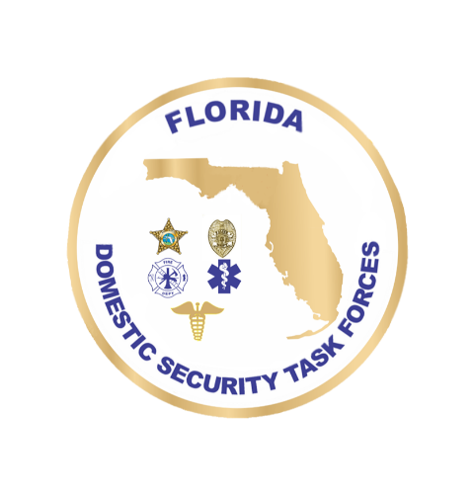
DOMESTIC SECURITY
OVERSIGHT COUNCIL
July 14, 2026 9:00 a.m. – 12:00 p.m.
Agenda
Welcome Ceremony Commissioner Mark Glass, FDLE

Roll Call Lyndsey Pitts, FDLE
Approval of June Minutes

Public Comment (9:15 – 9:45 A.M.)

Presentation

FY2026 NOFO Overview Lyndsey Pitts, FDLE

Action Item

FY26 Miami UASI Project Presentations Chief Grant Musser

FY26 Tampa Bay UASI Project Presentations Garry Lisiewski

FY26 Orlando UASI Project Presentations Captain Mitch Shaban

FY26 Jacksonville UASI Project Presentations Deputy Chief Jim Schaudel

FY26 SHSP Project Presentations DSAP, FDLE

Calendar
DSSP Workshop July 21-22, 2026 Tallahassee, FL
Focus Group Meetings September 1-3, 2026 Daytona Beach, FL
Executive Board Meeting October 14-15, 2026 TBD
DSOC Meeting November TBD, 2026 TBD

