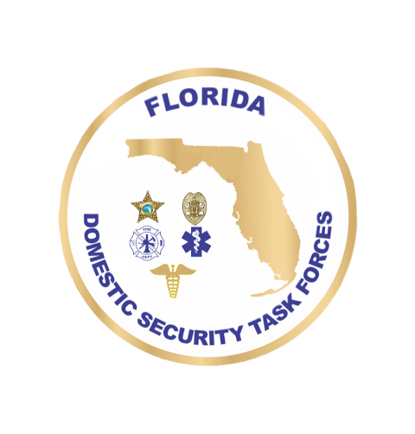**DOMESTIC SECURITY**

**OVERSIGHT COUNCIL**

**June 25, 2025 1:30 p.m. – 4:30 p.m.**

**Agenda**

Welcome Ceremony Commissioner Mark Glass, Roll Call FDLE

Approval of April Minutes

**Updates**

SHSP Funding Updates AC Mike Phillips, FDLE

Block Grant Ad Hoc Committee Update Director Kevin Guthrie, FDEM

DSOC Bylaws Jeff Dambly, FDLE

**Action Items**

SRT 5-Year Plans, SOGs, & Vehicle Requests Chief Robert Collins, TFR

PLEASE NOTE:

The following portion of the meeting is a “CLOSED SESSION” per F.S. 943.0314.

Only authorized personnel may attend. Thank you.

*Discussion of active criminal intelligence - DSOC members*

END of “CLOSED SESSION”

**Action Items**

FY26 DSOC Priorities Commissioner Mark Glass, FDLE

**Calendar**

DSCG Focus Group Meetings September 9-11, 2025 Orlando, FL

DSCG Executive Board Meeting October 15-16, 2025 St. Petersburg, FL

DSOC Meeting November 18, 2025 Destin, FL