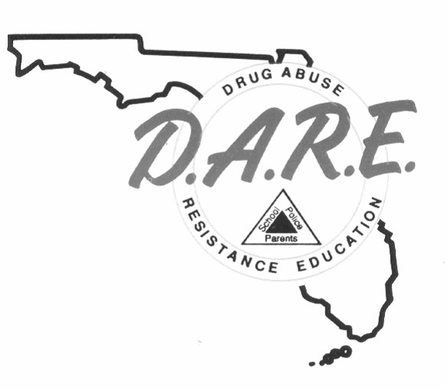

**D.A.R.E. OFFICER TRAINING**

**REGISTRATION FORM**

**TRAINING DATES: July 07-18, 2025** **LOCATION:** Miami, FL

**NAME** *(Print)*: **_____________________________ RANK/TITLE: _______________________**

**AGENCY: ___________________________________________________________________**

**ADDRESS: __________________________________________________________________**

**CITY: ____________________________________ STATE: ________ ZIP: _____________ PHONE: (_______) _______ - _________ EMAIL: __________________________________**

**PLEASE SELECT A CLASS BELOW:**

**Full-Time Class (80 Hours):** $500.00Tuition

**Recertification Class (40 Hours):** $250.00Tuition

**Please return completed Registration Form to:**

[DARE@fdle.state.fl.us](mailto:DARE@fdle.state.fl.us)

or

FDLE Capitol Police

Attn: D.A.R.E.

400 South Monroe Street, Suite 213

Tallahassee, FL 32399