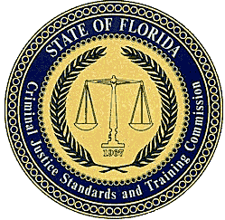
CRIMINAL JUSTICE STANDARDS AND
TRAINING COMMISSION
RULES AND FORMS EFFECTIVE: 9/4/16
2015-2016 Proposed Rule Revisions
RULE 11A-7: CRIMINAL JUSTICE STANDARDS AND TRAINING PROCEDURES
11A-7.002 Commission Procedures for Public Comment.
The Criminal Justice Standards and Training Commission invites and encourages all members of the public to provide comment on matters or propositions before the Commission or a committee of the Commission. The opportunity to provide comment shall be subject to the following:
(1) Members of the public will be given an opportunity to provide comment on subject matters before the Commission after an agenda item is introduced at a properly noticed Commission meeting.
(2) Members of the public shall be limited to five minutes to provide comment. This time shall not include time spent by the presenter responding to questions posed by Commission members, staff or Commission counsel. The chair of the Commission may extend the time to provide comment if time permits.
(3) Members of the public shall notify Commission staff in writing of his or her interest to be heard on a proposition or matter before the Commission. The notification shall identify the person or entity, indicate support, opposition, or neutrality, and identify who will speak on behalf of a group or faction of persons consisting of two or more persons. Any person or entity appearing before the Commission may use a pseudonym if he or she does not wish to be identified. The notification shall be submitted to Commission staff in writing to the Florida Department of Law Enforcement, Criminal Justice Professionalism Program, Post Office Box 1489, Tallahassee, Florida 32302.
Rulemaking Authority 943.03(4) 120.53(1), 286.0114 FS. Law Implemented 286.0114, 943.11(2) FS. History--New 9-4-16.

