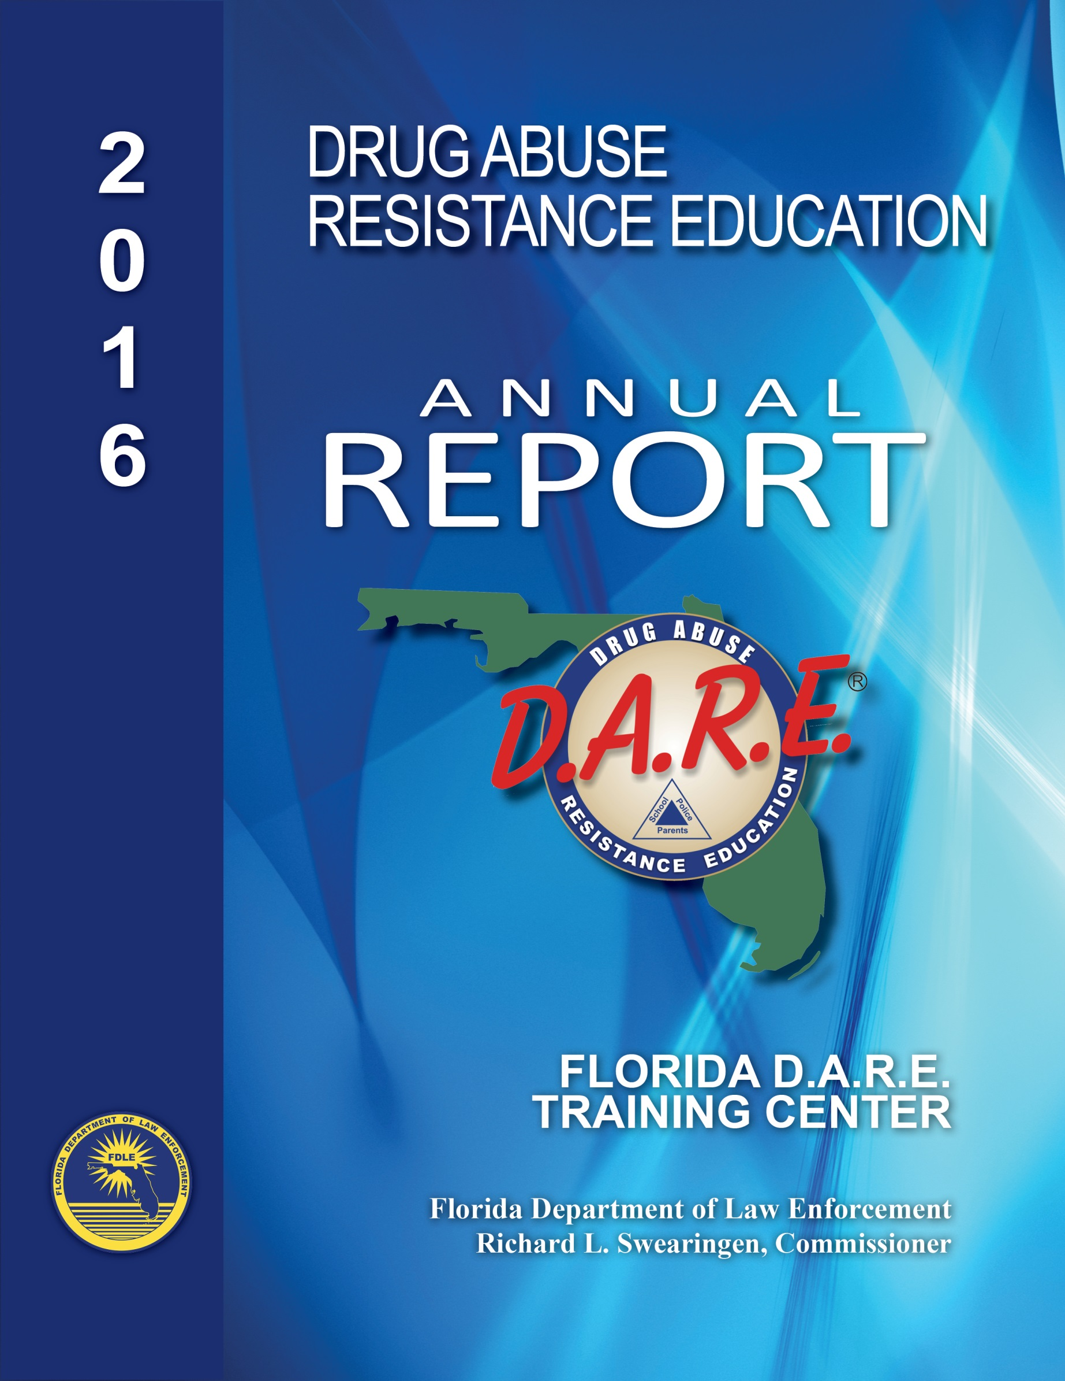
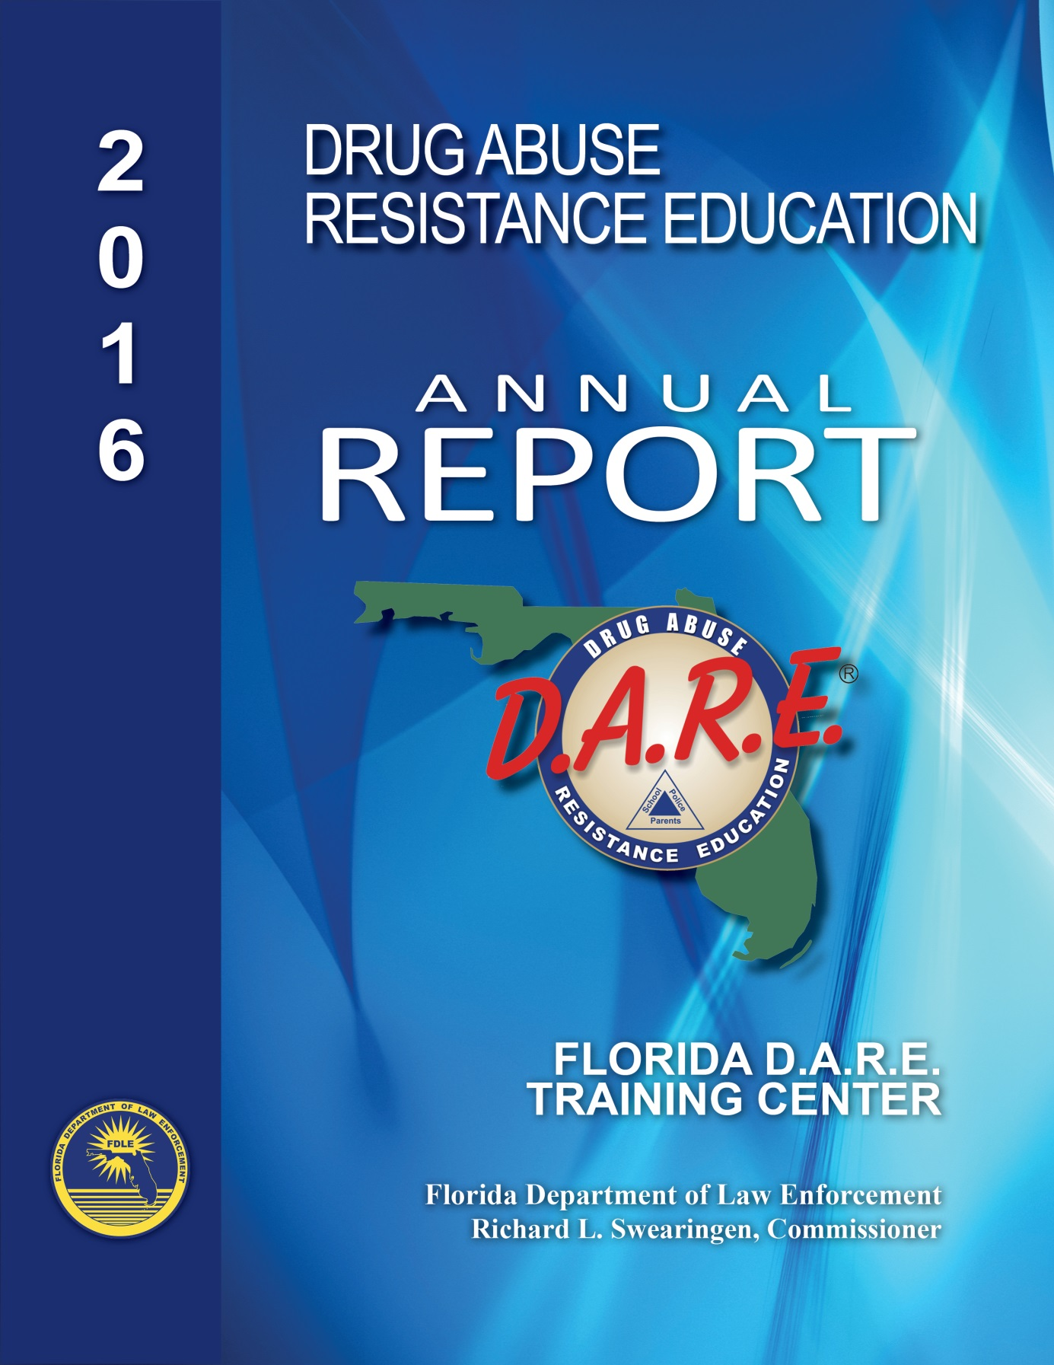
Table of Contents

Executive Summary Page 1
2016 Graduates Page 2
Making a Difference Page 3
Making the Pledge – Red Ribbon Campaign Week Page 3
Essay Contest Winner Page 4
Program Statistics Page 5-6
Calendar Year 2016 Expenditures Page 7

Executive Summary

The Florida Department of Law Enforcement (FDLE) has coordinated the Drug Abuse Resistance Education Program (D.A.R.E.) since 1988. D.A.R.E. is an international substance abuse prevention program administered within schools that seek to prevent use of controlled drugs, gang membership, and violent behavior. D.A.R.E. exemplifies teamwork between educators and law enforcement officers at the local level. This collaboration in drug prevention builds a strong foundation for the community to combat substance abuse.
The primary role and responsibility of FDLE in the D.A.R.E. Program is to serve as the state administrator for Florida. This administration includes, but is not limited to, developing guidelines for the Florida D.A.R.E. Program, serving as a liaison to the national D.A.R.E. policy making board, and training certification of D.A.R.E. officers. D.A.R.E. is a Criminal Justice Standards and Training Commission (CJSTC) approved Advanced Training Program course created to enhance an officer’s knowledge, skills, and abilities for the job the officer performs and upon agency approval can be used by an officer to satisfy mandatory retraining requirements or eligibility for salary incentive monies.
For the first time ever, FDLE celebrated National D.A.R.E. Day on April 21 at Florida’s Historic Capitol. Participants included D.A.R.E. officers from the Gadsden County Sheriff’s Office, the Winter Haven Police Department, and Valdosta (GA) Police Department. Each agency brought their D.A.R.E. vehicles for display. Children visiting the Capitol got a lesson on making good choices in life and had fun dancing to the D.A.R.E. song.
National D.A.R.E. Day is observed each year on the third Thursday of April. This is an occasion to celebrate the contributions and accomplishments of the D.A.R.E. curriculum and program, as well as honor the students who graduated from the program, D.A.R.E. officers, and the schools and law enforcement agencies supporting the program.
2016 D.A.R.E. Graduates

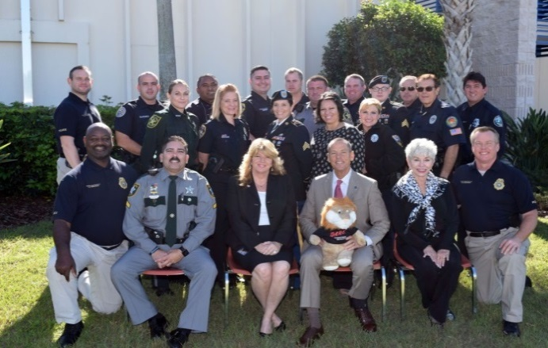
The D.A.R.E. Program drew participants from other states and across the globe. The officers and agencies making the commitment to the program include Broward, Collier, Hendry, Polk, Leon and Miami-Dade counties. The class also included officers from South Carolina, Arizona, Oregon, and Belgium.
D.A.R.E. Class #78
January 2016
The D.A.R.E. officers will take what they have learned back to the classroom and equip their kids with the skills to enable them to avoid negative influences. They will also teach them to focus on their strengths and potential to lead lives free from violence, substance abuse, and other dangerous behaviors.
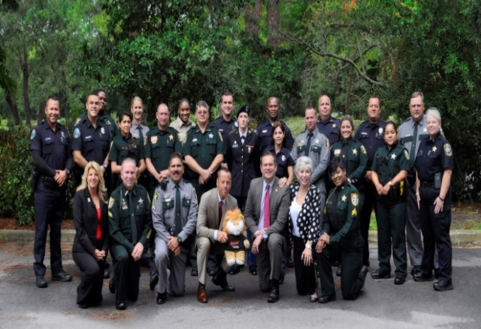

D.A.R.E. Class #79
August 2016

Florida D.A.R.E. Officers ~ Making a Difference in Florida
By: Sergeant Manny Saavedra, Sweetwater Police Department
Growing up, I had always heard about D.A.R.E., but I had never understood the importance of this program until I became a D.A.R.E. instructor.
After completing my D.A.R.E. instructor course, I came back to the Sweetwater Police Department full of ideas. Although I had the support of the Mayor and the Chief of Police it was very difficult to start the D.A.R.E. program for the first time in my city. Even the teachers and parents of our local schools did not understand the whole concept behind the D.A.R.E. program. They thought that D.A.R.E. consisted of different ways to say “NO TO DRUGS.”
We currently have launched our D.A.R.E. program for the first time in Sweetwater. We are on the 9th week of the program and I believe that the administration, as well as the teachers and parents of our local schools, have grasped the true concept of this crucial program in our community. D.A.R.E. is about decision making, communication skills, resistance strategies, responding to peer reassure, bullying, and confidence. These are just a few key points in an overall strategy to help our youth combat everyday situations seen in our schools. I have had many successes in my career as a law enforcement officer, but nothing has fulfilled me more than being a D.A.R.E. instructor. I encourage all municipalities in Miami-Dade County to participate in this life changing educational tool. Thank you for your time.
Making the Pledge – Red Ribbon Campaign Week

Recognizing Red Ribbon Campaign Week provides schools and communities the opportunity to unite and take a stand against drugs and alcohol. Events highlight the importance of the D.A.R.E. message and focus heavily on making appropriate and good decisions as these 5th graders mature and move onto middle school. Time is spent on the importance of picking good friends and having a supportive network of friends that make good decisions about their lives at home, during their free time, and at school.
In middle school, these young adults traditionally begin to experience more peer pressure and additional freedoms at home and after school. The D.A.R.E. program recognizes that this is the most likely time that they will be faced with some of the tough decisions we discuss in the program.

Florida D.A.R.E. Essay Contest
By: Emmarie, Osceola Elementary, Naples
Ms. Castor’s 5th Grade Class
Smoking… who wants your breath to smell like an ashtray? There’s also alcohol, which smells disgusting. But boy, oh boy do you want to know what that stuff does to you!
First of all, let’s look at smoking. It’s actually illegal for anyone under the age of eighteen, which can get you thrown in jail. More than four-hundred thousand Americans die each year from smoking, since cigarettes have more than 200 harmful chemicals. Smoking can cause you to have heart disease, some lung cancer, mouth cancer, tooth loss, and more. It also interferes with the brain, causes colds, upper-respiratory problems, and I’ll spare you the details of the gross –out tobacco video.
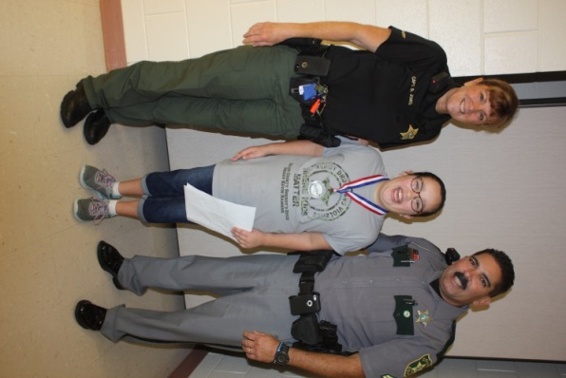
Then there’s also alcohol. Drinking alcohol is illegal for anyone under the age of twenty-one. Teen’s bodies also are affected more than adults, because teens are still growing. Oh, and drinking alcohol causes a loss of coordination, poor judgment, memory loss (or amnesia), a loss of self-control, and slow reflexes.
Did you know that your (or your child’s) peers can influence you negatively? You will begin to feel stressed, and you will disobey rules to be liked. You will start to get in trouble and do unhealthy things, like drugs. Stress can make you frustrated, dizzy, emotional, tired, and possibly make you fall into depression. Now… say your friend stole money from your teacher and threatens to blame you. That’s negative peer pressure.
There are also benefits to healthy lifestyle choices. If we think about how non-verbal communication makes others feel, we won’t accidently hurt others feelings. Also, not smoking or drinking will lead to a long happy life! If you treat others the way you want to be treated, it will come back to you, in positive ways.
Essay contest winner poses with: (from L to R)
Beth Jones, Captain of Collier County Youth Relations Bureau, Emmarie, and Corporal Kenneth Vila

So, now that you know about the harmful effects of things like smoking, alcohol, negative peer-pressure, and the benefits of heathy lifestyle choices, go out into the world and educate others.

Florida D.A.R.E. Program Statistics

Agency  (*New Agency) | Elem. Schools Taught | K-4 Students Taught | 5th/6th Grade Classes Taught | 5th/6th Grade Students Taught | Middle Schools Taught | 7th Grade Classes Taught | 7th Grade Students Taught | Certified D.A.R.E. Officers
Aventura Police Department | 1 | 700 | 6 | 120 | 0 | 0 | 0 | 1
City of Doral Police Department | 8 | 0 | 54 | 1,305 | 0 | 0 | 0 | 10
City of Margate Police Department | 3 | 1,257 | 19 | 458 | 0 | 0 | 0 | 5
Coconut Creek Police Department | 3 | 215 | 16 | 360 | 0 | 0 | 0 | 3
Collier County Sheriff's Office | 39 | 17,500 | 190 | 3,800 | 0 | 0 | 0 | 50
Coral Gables Police Department | 1 | 0 | 3 | 105 | 0 | 0 | 0 | 2
DeLand Police Department | 6 | 0 | 23 | 615 | 0 | 0 | 0 | 2
Eatonville Police Department | Did | Not | Report
Florida Dept. of Law Enforcement | 1 | 50 | 0 | 0 | 0 | 0 | 0 | 1
FL School for the Deaf & Blind PD | 2 | 78 | 5 | 42 | 0 | 0 | 0 | 1
Florida State University PD | Did | Not | Report
Gadsden County Sheriff's Office | 9 | 662 | 21 | 428 | 7 | 14 | 320 | 6
Gilchrist County Sheriff’s Office*
Gulf County Sheriff's Office | 2 | 0 | 7 | 138 | 2 | 7 | 147 | 2
Hallandale Beach Police Department* | 6 | 243 | 8 | 189 | 0 | 0 | 0 | 1
Hendry County Sheriff’s Office | 5 | 0 | 21 | 540 | 0 | 0 | 0 | 4
Highlands County Sheriff's Office | 12 | 0 | 48 | 970 | 0 | 0 | 0 | 8
Holmes Beach Police Department | 1 | 60 | 2 | 42 | 0 | 0 | 0 | 3
Indian River County Sheriff’s Office | 11 | 400 | 43 | 1,010 | 0 | 0 | 0 | 7
Key Biscayne Police Department | 2 | 205 | 9 | 248 | 0 | 0 | 0 | 1
Lake County Sheriff’s Office*
Marco Island Police Department | 1 | 200 | 5 | 100 | 0 | 0 | 0 | 3
Martin County Sheriff’s Office | 13 | 0 | 70 | 1,500 | 1 | 6 | 140 | 9
Miami Police Department | 45 | 0 | 210 | 6,735 | 0 | 0 | 0 | 12
Miami-Dade County/  Village of Palmetto Bay | 4 | 0 | 25 | 530 | 0 | 0 | 0 | 1

Florida D.A.R.E. Program Statistics
(Continued)

Agency  (*New Agency) | Elem. Schools Taught | K-4 Students Taught | 5th/6th Grade Classes Taught | 5th/6th Grade Students Taught | Middle Schools Taught | 7th Grade Classes Taught | 7th Grade Students Taught | Certified D.A.R.E. Officers
Miccosukee Police Department*
Naples Police Department | 3 | 0 | 14 | 300 | 0 | 0 | 0 | 4
Nassau County Sheriff’s Office | 7 | 25 | 39 | 872 | 0 | 0 | 0 | 1
New Smyrna Beach Police Department | 4 | 1,000 | 26 | 600 | 1 | 7 | 175 | 1
Ocala Police Department | 11 | 0 | 37 | 751 | 1 | 4 | 120 | 4
Ocoee Police Department | 5 | 0 | 29 | 638 | 0 | 0 | 0 | 1
Okeechobee County Sheriff’s Office | 7 | 0 | 22 | 484 | 0 | 0 | 0 | 10
Orange City Police Department | 2 | 100 | 11 | 125 | 0 | 0 | 0 | 3
Orange Park Police Department | Did | Not | Report
Ormond Beach Police Department | 9 | 0 | 9 | 619 | 0 | 0 | 0 | 2
Oviedo Police Department | Did | Not | Report
Pinecrest Police Department | 2 | 10 | 13 | 320 | 0 | 0 | 0 | 2
Pinellas Park Police Department | 6 | 100 | 25 | 510 | 0 | 0 | 0 | 2
Punta Gorda Police Department | 1 | 0 | 5 | 100 | 0 | 0 | 0 | 1
Sarasota County Sheriff’s Office | 2 | 0 | 14 | 305 | 0 | 0 | 0 | 2
Sebastian Police Department | 3 | 75 | 8 | 210 | 0 | 0 | 0 | 1
Sebring Police Department | 1 | 0 | 5 | 110 | 0 | 0 | 0 | 1
Seminole Police Department | 1 | 31 | 2 | 8 | 0 | 0 | 0 | 1
Sunny Isles Beach Police Department | 1 | 0 | 10 | 260 | 0 | 0 | 0 | 2
Sweetwater Police Department*
Vero Beach Police Department | 3 | 0 | 9 | 227 | 1 | 1 | 28 | 3
West Miami Police Department | 1 | 0 | 3 | 60 | 0 | 0 | 0 | 1
Winter Haven Police Department | 9 | 1,000 | 38 | 750 | 0 | 0 | 0 | 1
2016 – 40 Reported | 253 | 23,911 | 1,104 | 26,484 | 13 | 39 | 930 | 175

Calendar Year 2016 Expenditures

 |  |  | January thru December
Salaries and Benefits |  |  | $ 162,284.11
Expenses | Telephone |  | $ 338.38
 | Postage |  | $ 61.86
 | Printing |  | $ 607.68
 | Travel |  | $ 21,201.77
 | Supplies |  | $ 2,601.19
 | Conf. Registration Fees |  | $ 672.00
 | Property Rental/Trainings |  | $ 600.24
 | Total |  | $ 26,083.12
Contracted Services | Training |  | $ 7,500.00
 | Mail Service |  | $ 87.40
 | Total |  | $ 7,587.40
Total Estimated* Expenses for 2016 |  |  | $ 195,954.63
*Reconciling 2016 expenses

